**Technological Institute of the Philippines**

**Quezon City**

**COMPUTER SCIENCE DEPARTMENT**

**STUDENT PORTFOLIO**

**CS 402 – INTERNSHIP IN COMPUTING**

**GENREV DALE E. ZAPA**

**JUNE 2022**

**Technological Institute of the Philippines**

**Quezon City**

**COMPUTER SCIENCE DEPARTMENT**

**Assessment of Student Outcomes**

**CS 402 – INTERNSHIP IN COMPUTING**

**The following Assessment Tasks support the attainment of the following Student Outcomes:**

SO 1. Analyze a complex computing problem and apply principles of computing and other relevant disciplines to identify solutions;

SO 2. Design, implement, and evaluate a computing-based solution to meet a given set of computing requirements in the context of the program’s discipline;

SO 3. Communicate effectively in a variety of professional contexts;

SO 4. Recognize professional responsibilities and make informed judgments in computing practice based on legal and ethical principles;

SO 5. Function effectively as a member or leader of a team engaged in activities appropriate to the program’s discipline; and

S6. Apply computer science theory and software development fundamentals to produce computing-based solutions.

**Technological Institute of the Philippines**

**Quezon City**

**College of Information Technology Education**

**Computer Science Department**

**On- the-Job Training FINAL WRITTEN REPORT**

**Second Semester, School Year 2021-2022**

**EPLAYMENT**

**Submitted by:**

**Zapa, Genrev Dale E.**

**CS42S2**

**Submitted to:**

**Reynaldo E. Castillo**

**OJT Faculty-in-Charge**

**JUNE 202**

# ON-THE-JOB TRAINING FINAL WRITTEN REPORT

# Second Semester, School Year 2021-2022

**Eplayment Corporation**

LG3 Capitol Greenstreet, 1 Capitol Drive, Matandang Balara, Quezon City, 1119 Metro Manila

# Acknowledgement

I would like to thank Aunt Marianne for taking care of me throughout my OJT. She has been actively helping me physically by readying me food to eat and helping me emotionally by encouraging me at times I feel like I want to surrender.

I would also like to thank my brother, uncle for supporting me financially so that I could enroll and experience quality education. To my family that keeps on reminding me not to lose sight of what originally my goals are as I enter to college.

To sir Rey Castillo, our OJT faculty-in-charge, who has been there for me from start until end. I deeply appreciate the effort you put for us to experience what its like to work outside. I am thankful and undeserving of the patience you showed to me despite my obvious flaws and shortcomings.

To sir Karlos Naidas, the CEO of the company that I worked with, I am deeply grateful for letting me be a part of his company. And to Andrea Echano, our project manager, who guided, taught, instructed, and provided me the tasks I enjoyed very much. Also, I would also like to thank all my co-workers that shared with me insights and inspirations so that my passion for learning does not stop.

Lastly, I would like to thank God for giving me this once of a lifetime chance. And to myself, who persevered. Thank you.

# TABLE OF CONTENTS

**Title Page**

**Acknowledgement**

1. **Company Data**
2. Brief History/Background of the Company/Company Profile
3. Inclusive dates of training
4. Name(s) of Personnel (supervisor, liaison officer, training officers/instructors, etc.) involved in the training program with their respective designations
5. **Brief Description of the Training Program**
6. Institutional Intended Learning Outcomes (IILOs) Addressed by OJT/Practicum Course
7. Student Outcomes (SOs) Addressed by the OJT/Practicum Course
8. Objectives
9. Schedule/Timetable
10. Areas of Training
11. Reference Materials (e.g., Manuals, textbooks, etc.,) used during the training
12. **Compiled Weekly and Month Reports**
13. **Personal Evaluation of the Training Program**
14. Professional Learning and Development Achieved
15. Modern Techniques, Skills and Tools Used/Learned
16. Equipment, Machinery, Testing Apparatus, etc., Handheld
17. Experiences with the Company Personnel Involved in the Training
18. Best Practices Used/Applied
19. Discipline Related Solutions Integrated into the Company
20. Strong Points
21. Weak Points and Suggested Solutions
22. **Recommendations**
23. Potential of the Company as a Training Ground

* Availability and Appropriateness of Facilities, Equipment, and Machinery
* Company Personnel Cooperation

1. Duration of Training
2. Suggestions for the Improvement of the Training Program
3. Advice to Future On-the-Job Trainees
4. **Success Story**
5. **Job Hunting Experience**
6. **Appendices**
7. Request for OJT Endorsement Letter Form
8. Endorsement Letter
9. Certification of Acceptance for OJT
10. Winning Mindset Reflection Paper and Certificate
11. Practice Mock Job Interview Reflection Paper and Certificate
12. Certificate of Completion ( from company)
13. Trainee’s Curriculum Vitae from ARIS
14. OJT/Internship Evaluation Form
15. Student Performance Rating (Students Outcomes Rubrics)
    1. Grading Rubrics from the Company (Signed by your Supervisor)
    2. Individual Rubric Forms (SOs 1 to 6 Signed by OJT Faculty-in-Charge)
16. OJT Student’s Company Job Hunting Record
17. Snippets
18. OJT/Practicum Agreement and Liability Waiver for the Company (Optional)
19. Student’s Parent’s Waiver (Optional)

# COMPANY DATA

**Company Data**

1. **Brief History/Background of the Company/Company Profile**



Eplayment Corporation is a Fintech (financial technology) company that specifically offers an e-wallet for gamers and creators that enables them to make easy, fun, and secure transactions across multiple platforms. They began at the grassroots, creating gaming and esports content which encountered firsthand the hurdles in creative freedom and creator monetization.

Having a newfound drive to solve the structural problem, they entered the world of fintech which directed the development of a payment gateway for businesses in gaming and entertainment.

After months of development, they released a beta of their flagship product which is the Eplayment Wallet. This version can be used for fund transfers and digital purchases of game and entertainment credits.

Eplayment's mission is to bring the world of virtual finance and entertainment to everyone as a fun, secure, and convenient fintech institution. Whereas their vision is that they see a digital space to securely engage with people in and experience the fullest potential of fintech and entertainment combined.

1. **Inclusive Dates of Training**

My On-the-Job Training started on February 28, 2022, and completed April 19, 2022

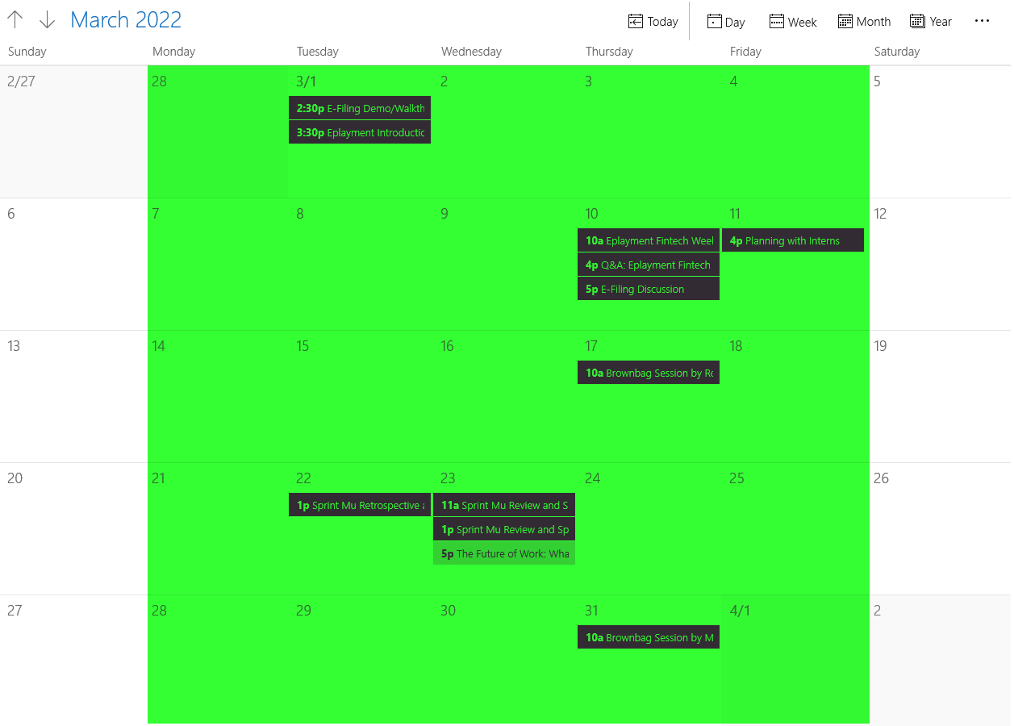

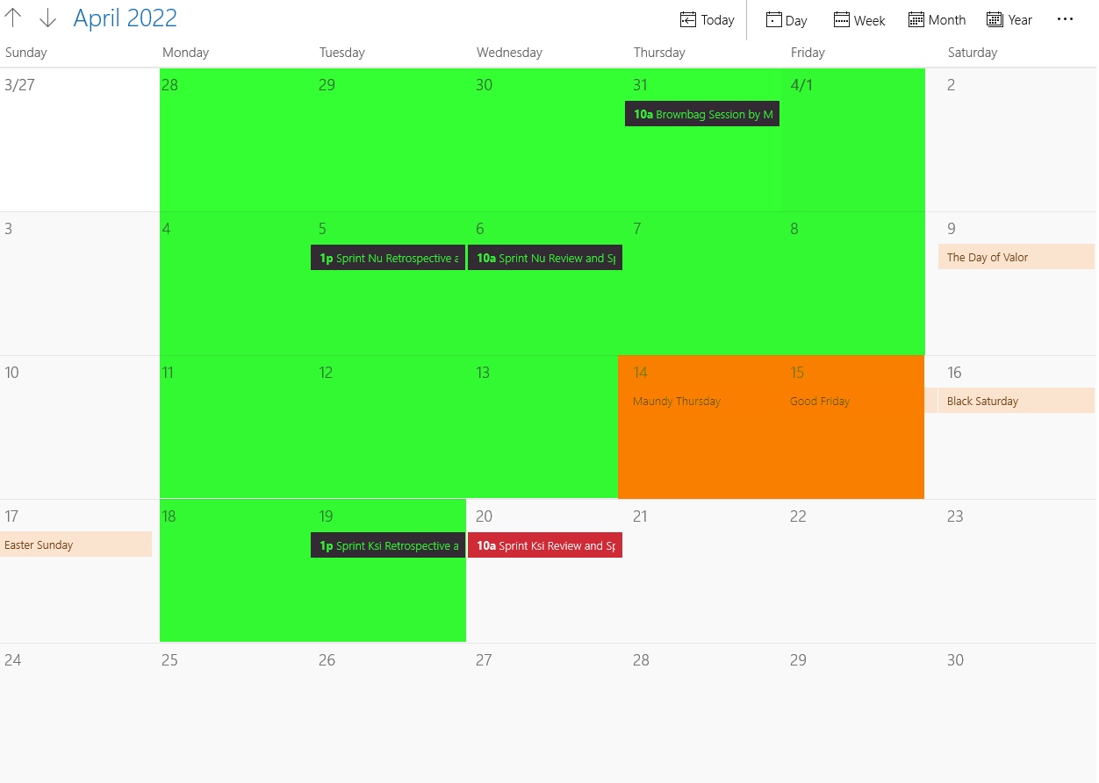

Legends

– Attended

– Holiday

1. **Name(s) of Personnel involved in the training program with their respective designations**

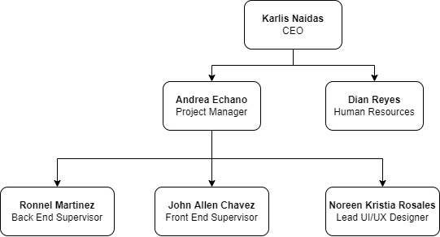

* + 1. **DESCRIPTION OF THE TRAINING PROGRAM**

**Description of the Training Program**

1. **Brief Description of the Training Program**

The TIP On-the-Job Training (OJT) Program is designed in fulfillment of the school’s mission to transform students into graduates with full competence in their fields of study. Provide the students an opportunity to be exposed in an actual work setting and assimilate their academic learning into practical applications. Develop and instill among students the industry-desired values of positive work attitude, good human relations, competency in technical skills that pertain to their field of study, and the openness to keep on learning to reinvent themselves.

With the ongoing pandemic, TIP OJT has switched in providing the student a work-from-home setting whilst having the same quality of experience. It provides guidelines on how students can be carefully placed with industry partners to have an opportunity to meet specific developmental outcomes while applying a variety of knowledge and skills learned throughout the program. It also provides guidelines on how students prepare proper and unified documentation of reports.

1. **Institutional Intended Learning Outcomes (IILOs) Addressed by OJT/Practicum Course**

The following IILOs are addressed by OJT/Practicum Course:

* **Communication skills**. Apply effective communication skills, both orally and in writing, using the English language.
* **Lifelong Learning.** Utilize lifelong learning skills in pursuit of personal development and excellence in professional practice.
* **Social and Ethical Responsibility.** Hold personal values and beliefs as ethical professional consistent with Filipino family values, industry-desired values and global citizen values.
* **Productivity.** Contribute to nation-building and national development through application of technology.
* **Interpersonal Skills.** Work effectively in multi-disciplinary and multi-cultural teams.

1. **Student Outcomes (SOs) Addressed by the OJT/Practicum Course**

* **Information Technology:** This final written report supports the attainment of the following Student Outcomes:

**SO(d)** Use modern techniques, skills, and tools of computing practice in complex computing activities;

**SO(e)** Function effectively as an individual and as a member or leader in diverse teams and in multi-disciplinary settings;

**SO(f)** Communicate effectively about complex computing activities with various communities, such as computing experts and society at large, using appropriate levels of discourse;

**SO(h)** Understand professional, ethical, legal, security, and social issues and responsibilities relevant to professional computing practice;

**SO(i)** Recognize the need for, and have the ability to engage in continuous professional development and lifelong learning; and

**SO(l)** Integrate IT based solutions into the user environment effectively.

1. **Objectives** *(sample only – be sure that all objectives are achieved in your report)*

* Develop the value of professionalism, love of work and commitment to people they serve;
* Immerse your capabilities to be exposed and trained in industry-level skills;
* Acquire core programming foundation to prepare the student to be flexible and efficient when assigned to completely different tools and techniques;
* Impart essential knowledge to co-workers to enlighten them out of confusion;
* Learn how to create APIs and implement it on an application;
* Develop apps for both Android and iOS platform;
* Apply different project architecture for application maintainability;
* Integrate libraries to increase the functionality of the application; and
* Enable user interactivity in mobile application development on different platforms.

1. **Schedule /Timetable**

|  |  |  |  |  |  |
| --- | --- | --- | --- | --- | --- |
| Day | Monday | Tuesday | Wednesday | Thursday | Friday |
| Time | 8:00AM - 5:00PM | 8:00AM - 5:00PM | 8:00AM - 5:00PM | 8:00AM - 5:00PM | 8:00 AM - 5:00PM |

1. **Areas of Training** includes course related to the software engineering, big data, application, design, development, implementation, support or management of computer-based information systems, software and hardware related to participants’ automation investment.

The areas of my training are the following: *(sample only – write your trainings*

* **Quality Assurance Training** is the systematic process of determining whether products meet customers' expectations. ASQ's quality assurance training courses can help teach you how to avoid problems when delivering solutions or services to customers.
  + Quality Assurance (Tester)
* **Mobile App Development Training** learns to build responsive and robust mobile applications using the most in-demand programming languages for Android and IOS including Java, C# and Swift. Gain skills in responsive web design, enterprise integration, and learn to implement mobile data security best practices. Design secure mobile applications for iPhone and Android.
  + Back-End Web Developer
  + Android Developer
  + iOS Developer

## Graphic Design Training fuses creativity and technology to create visually engaging graphics that communicate a message.

* + Graphical Designer

1. **Reference Materials** *(sample only – include all tools used during OJT*

The available materials, internet, booklets are used in the company which I choose and apply in my computing activities during my internship period. I also use different software like:

* Scrum Methodology
* Realm Database
* Retrofit library for HTTP Communication
* Model-View-Presenter (MVP) Architecture for project structures
* Postman
* Blender
* Unity and Xcode
* Android Studio, Unity
* PHP Slim Framework
* PostgreSQL
* iOS UI/UX Libraries

* + 1. **COMPILED WEEKLY AND MONTHLY REPORTS**

### Week 1: February 28, 2022 – March 4, 2022

STUDENT NAME: Genrev Dale E. Zapa COMPANY: Eplayment Corporation PROGRAM: BS Computer Science

|  |  |  |  |
| --- | --- | --- | --- |
| **DAY** | **DATE** | **DAILY ACCOMPLISHMENTS** | **NO. OF WORKING HOURS** |
| Monday | February 28, 2022 | * Studied Laravel 8 Framework - The Basics * Studied Laravel 8 framework - Blade * Studied Laravel 8 framework - Working With Databases * Quick discussion with project manager Andrea Echano   Software/Tools used: PhpStorm, Laravel, MariaDB, Discord, Google Chrome | 8 |
| Tuesday | March 1, 2022 | * Studied Laravel 8 framework - Integrate the Design * Studied Laravel 8 framework - Search * Studied Laravel 8 framework - Filtering * Reviewed Bootstrap/CSS * Studied Tailwind * Meeting (E-Filing Demo/Walkthrough and Eplayment Introduction) with the CEO Karlos Naidas   Software/Tools used: PhpStorm, Laravel, MariaDB, Bootstrap, Tailwind, GoogleMeet, Discord, Google Chrome | 8 |
| Wednesday | March 2, 2022 | * Studied Laravel 8 framework - Pagination * Studied Laravel 8 framework - Forms and Authentication * Studied Laravel 8 framework - Comments * Studied Docker * Set environment for development   Software/Tools used: PhpStorm, Laravel, MariaDB, Tailwind, GoogleMeet, Discord, Google Chrome, Git, GitHub, Docker, WSL2 | 8 |
| Thursday | March 3, 2022 | * Studied Laravel 8 framework - Newsletters and APIs * Studied Laravel 8 framework - Admin Section * Studied Laravel 8 framework - Conclusion * Studied Laravel 8 framework - Conclusion * Studied Inertia.js * Watched Agile and Scrum training video by our project manager Andrea Enchano   Software/Tools used: PhpStorm, Laravel, MariaDB, Tailwind, Google Chrome, Docker, WSL2 | 8 |
| Friday | March 4, 2022 | * Studied Inertia.js * Studied the fundamentals of React.js * Studied basics of Typescript   Software/Tools used: PhpStorm, Laravel, MariaDB, Tailwind, Google Chrome, Docker, WSL2 | 8 |

**TOTAL NO. OF HOURS**: 40

#### Week 1 Screenshots

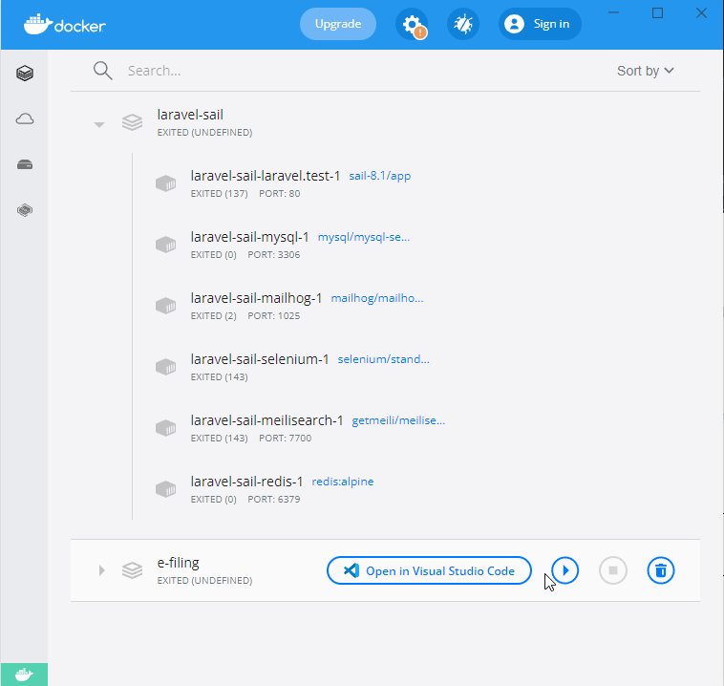

Setup Environment for Docker

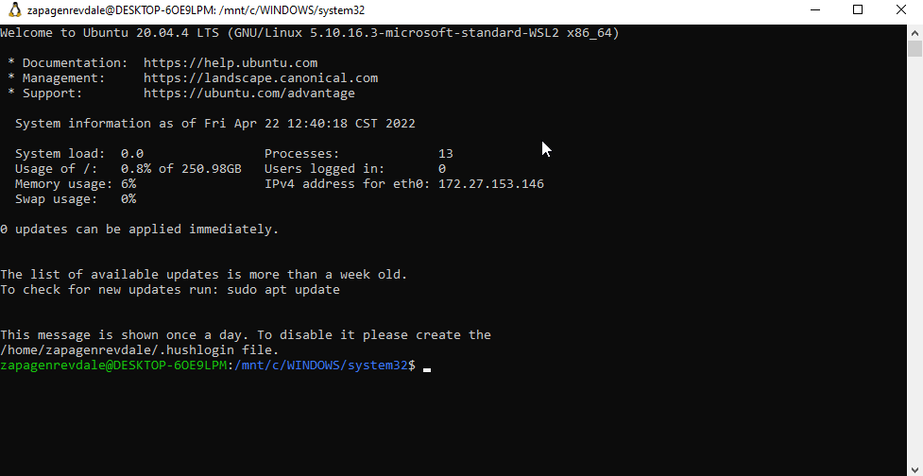

Use of WSL2 for Docker

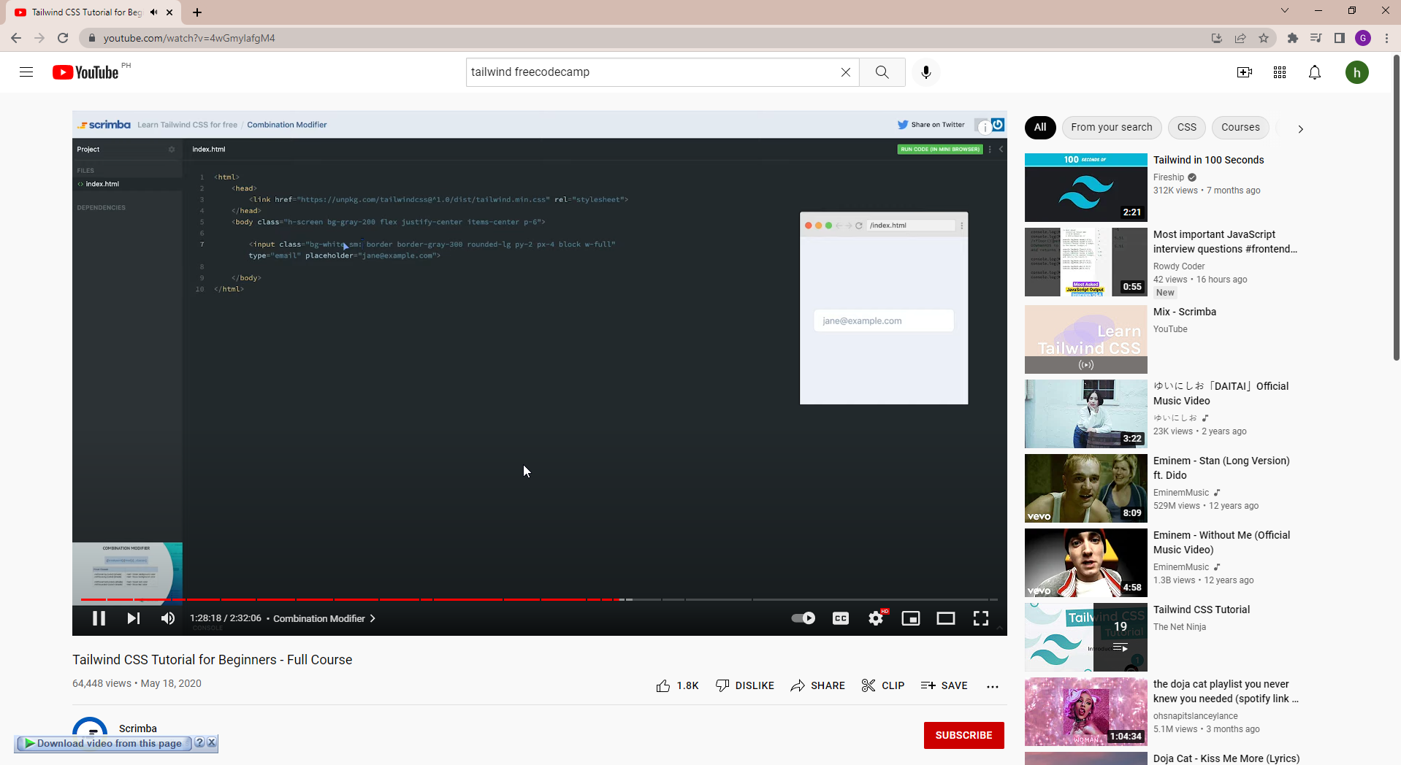

Studied Tailwind css

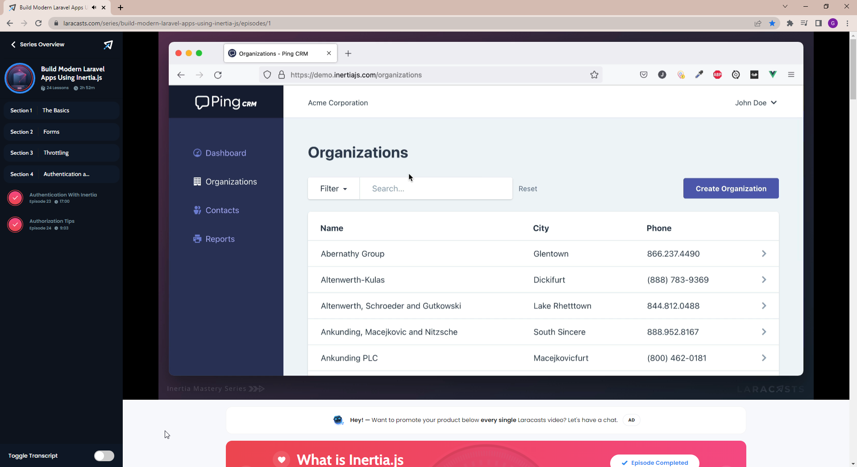

Studied Inert.js

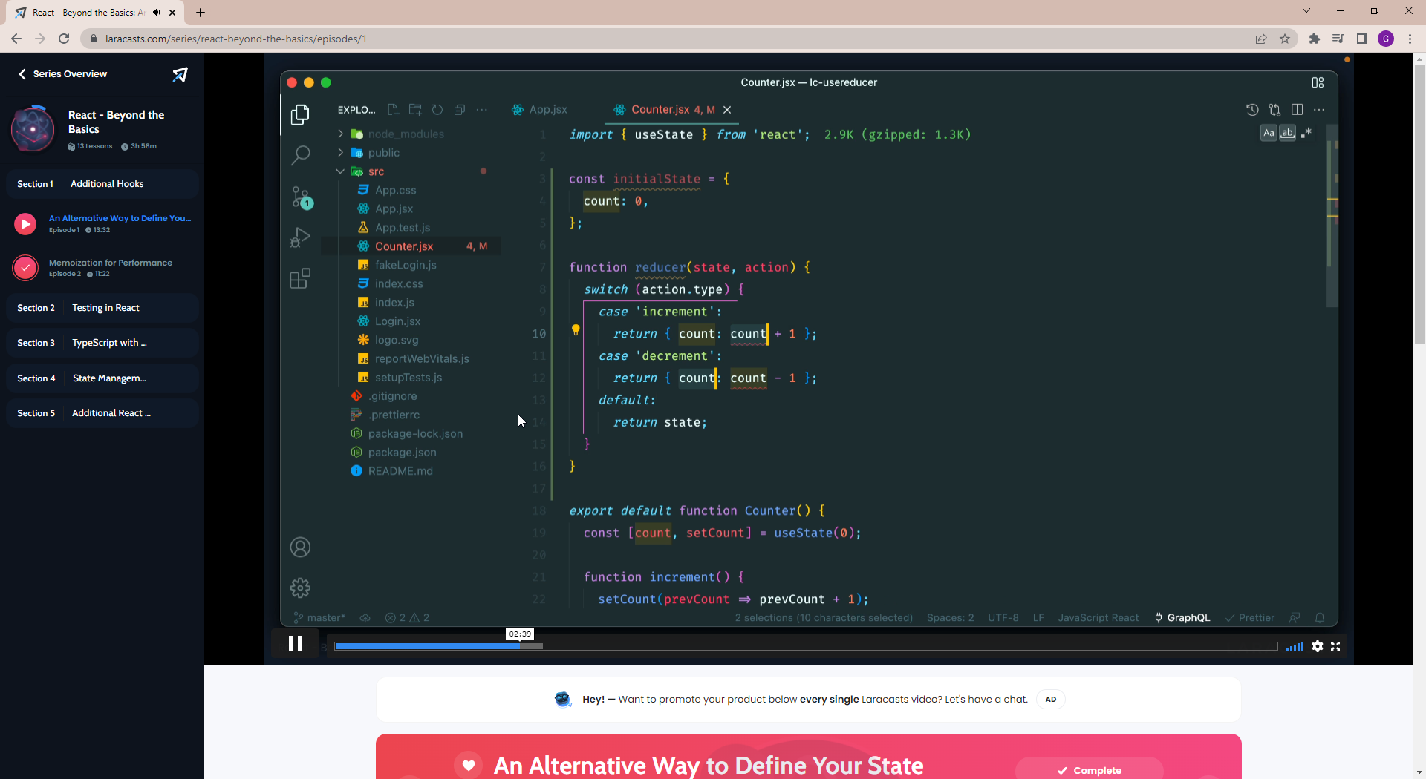

Studied React.js/tsx with Laravel and Inertia

### Week 2: March 7, 2022 – March 11, 2022

STUDENT NAME: Genrev Dale E. Zapa COMPANY: Eplayment Corporation PROGRAM: BS Computer Science

|  |  |  |  |
| --- | --- | --- | --- |
| DAY | **DATE** | **DAILY ACCOMPLISHMENTS** | **NO. OF WORKING HOURS** |
| Monday | March 7, 2022 | * Studied the E-filing Figma * Create/Anaylize ERD for E-filing * Studied React.js * Studied Spatie/Laravel-permission * Started designing the landing page * Daily Stand Up meeting   Software/Tools used: PhpStorm, Laravel, MariaDB, Figma, Draw.io, Discord, Google Chrome | 8 |
| Tuesday | March 8, 2022 | * Rewrite ERD for E-filing * Studied Tailwindcss * Created Layout.js using React/Inertia/Tailwind/Laravel for front-end * Designed Layout.js according to E-filing wireframe in Figma * Daily Stand Up meeting   Software/Tools used: PhpStorm, Laravel, MariaDB, Figma, Draw.io, Discord, Google Chrome, React | 8 |
| Wednesday | March 9, 2022 | * Finished the navbar for the layout (temporary icons and css designs) * Program the sidebar for the layout * Integrated the assets from figma (icons, images, etc..) to the public folder * Rewrite coded modules in typescript. From Layout.js to Layout.tsx * Started coding the add employee form (Create.tsx). * Daily Stand Up meeting   Software/Tools used: PhpStorm, Laravel, MariaDB, Figma, Draw.io, Discord, Google Chrome, React, Typescript, | 8 |
| Thursday | March 10, 2022 | * Added and edited the tailwind configurations based on figma designs * Added new tailwind classes based on the design in figma * Finished the Add employee form (no functionality yet) * Pulled Philippine geography datasets from Sir Ronnel's repo, fixed errors on database connection upon pulling * As per the supervisor's (Sir Allen) suggestion, I used his json dataset instead so that I can do client side request on province/city/region lists. * Daily Stand Up meeting   Software/Tools used: PhpStorm, Laravel, MariaDB, Figma, Discord, Google Chrome, React, Typescript, Git, Github | 8 |
| Friday | March 11, 2022 | * Tried to integrate the json dataset, however, it was not applicable because it does not contain data for Philippine regions. * Created own philippine geography data in json format * Integrated the philippine geography json data in forms * Rewrote code so that the form components are reusable * Start integrating the add employee form to backend. Created the EmployeeController. * Daily Stand Up meeting * E-Filing Planning/Discussion with Project Manager and co-intern   Software/Tools used: PhpStorm, Laravel, MariaDB, Figma, Discord, Google Chrome, React, Typescript, Git, Github | 8 |

**TOTAL NO. OF HOURS** : 40

#### Week 2 Screenshots

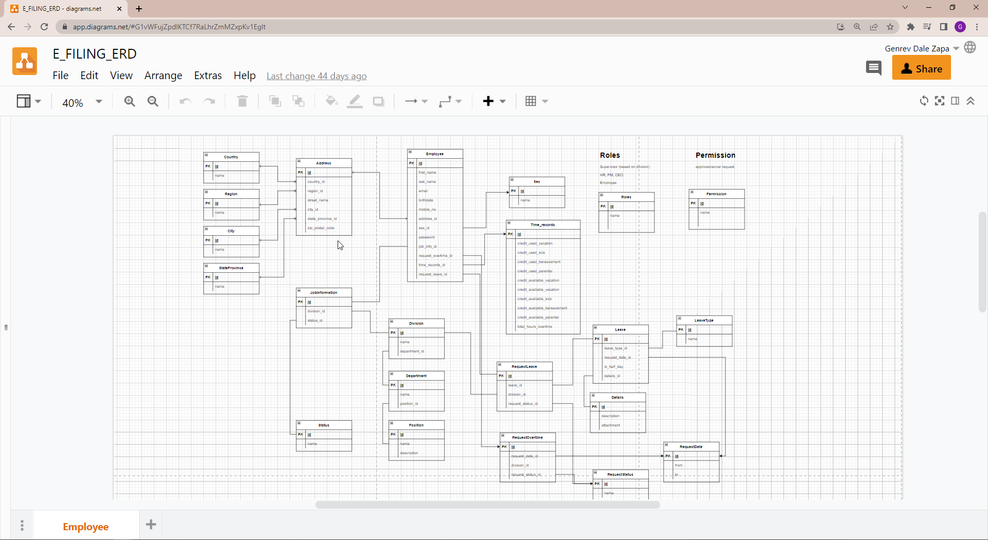

Designed ERD

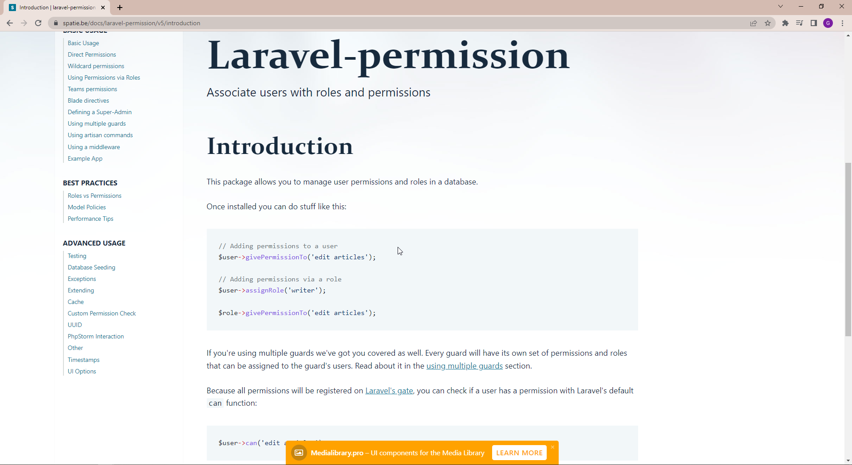

Studied documention of Spati Laravel-Permission

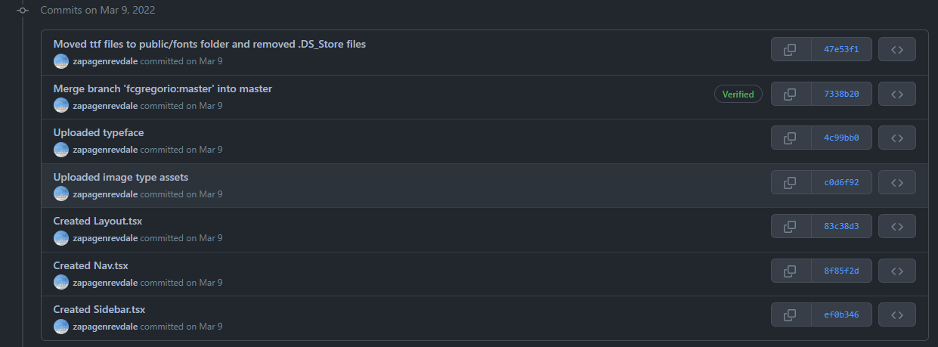

Committed tasks available on GitHub by March 9, 2022

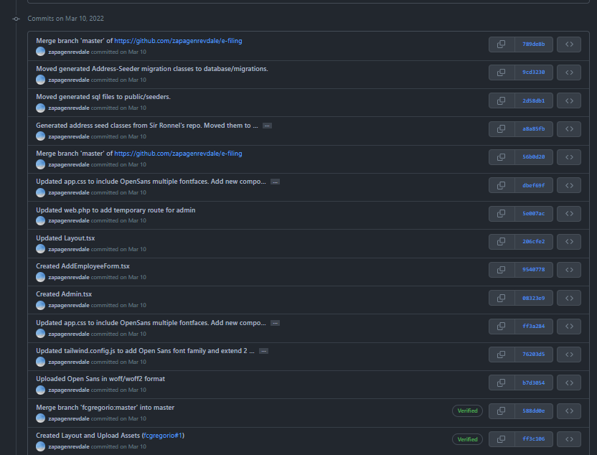

Committed tasks available on GitHub by March 10, 2022

### Week 3: March 14, 2022 – March 18, 2022

STUDENT NAME: Genrev Dale E. Zapa COMPANY: Eplayment Corporation PROGRAM: BS Computer Science

|  |  |  |  |
| --- | --- | --- | --- |
| DAY | **DATE** | **DAILY ACCOMPLISHMENTS** | **NO. OF WORKING HOURS** |
| Monday | March 14, 2022 | * Implemented the *create* action (a function that renders the Employee/Create.tsx page) on EmployeeController. * Created an enum file for employee status attribute and implemented it in store action. * Updated Factory classes UserFactory and AddressFactory based on the changes on EmployeeController and EmployeeStatus enum. * Updated User/Address model fillables as a result to the implementation of enum and updates on Factory classes. * Updated the user migration table based on the changes mentioned above. * Commmit staged changes and pushed in Github. * Created pull request to the master branch. * Daily Stand Up Meeting   Software/Tools used: PhpStorm, Laravel, MariaDB, Figma, Discord, Google Chrome, React, Typescript, Git, Github | 7.85 |
| Tuesday | March 15, 2022 | * Checked comments/review left by my co-intern Francis Gregorio on my pull request. * Implemented user instance creation by adding EmployeeController *store* action (a function that saves created user instance to the database). * Small design/error handling updates on Admin.tsx, Nav.tsx, and AddEmployeeForm.tsx. * Updated web.php by adding new route for employee creation/registration * Revert changes to address model/migration by following<https://schema.org/PostalAddress>, a standard schema for address. * Commmit staged changes and pushed in Github and merge changes from the master branch * Implemented remaining comments from my pull request such as deleting unused components, removing division/department relationship upon user creation. * Daily Stand Up Meeting   Software/Tools used: PhpStorm, Laravel, MariaDB, Figma, Discord, Google Chrome, React, Typescript, Git, Github | 8 |
| Wednesday | March 16, 2022 | * Created the Employee/Index.tsx page and designed the section for departments info. * Implemented the EmployeeController index() so that the data of required for indexing employee is provided. * Updated tailwind configuration and added new styles in app.css * Implemented the search and sort button components * Studied the implementation of my co-intern (Francis Gregorio) on form and store operation. * Daily Stand Up Meeting   Software/Tools used: PhpStorm, Laravel, MariaDB, Figma, Discord, Google Chrome, React, Typescript, Git, Github | 7.25 |
| Thursday | March 17, 2022 | * Finalized the implementation of indexing of employees in the Employee/Index.tsx page. (Frontend) * Optimized how the EmployeeController index() is implemented. * Implemented search in the Employee/Index page. * Updated tailwind configuration and added new styles in app.css * Studied the implementation of my co-intern (Francis Gregorio) on store operation.   Software/Tools used: PhpStorm, Laravel, MariaDB, Figma, Discord, Google Chrome, React, Typescript, Git, Github | 8 |
| Friday | March 18, 2022 | * Created Employee/Show page and implemented the banner of the page. * Implemented a static component of leave details. * Implemented show() in EmployeeController so that the data needed for the page is provided from backend. * Updated routing in web.php to connect with EmployeeController * Refined the code from Employee/Index page * Commmit staged changes and pushed in Github and merge changes from the master branch * Daily Stand Up Meeting   Software/Tools used:PhpStorm, Laravel, MariaDB, Figma, Discord, Google Chrome, React, Typescript, Git, Github | 8 |

**TOTAL NO. OF HOURS**: 39.1

#### Week 3 Screenshots

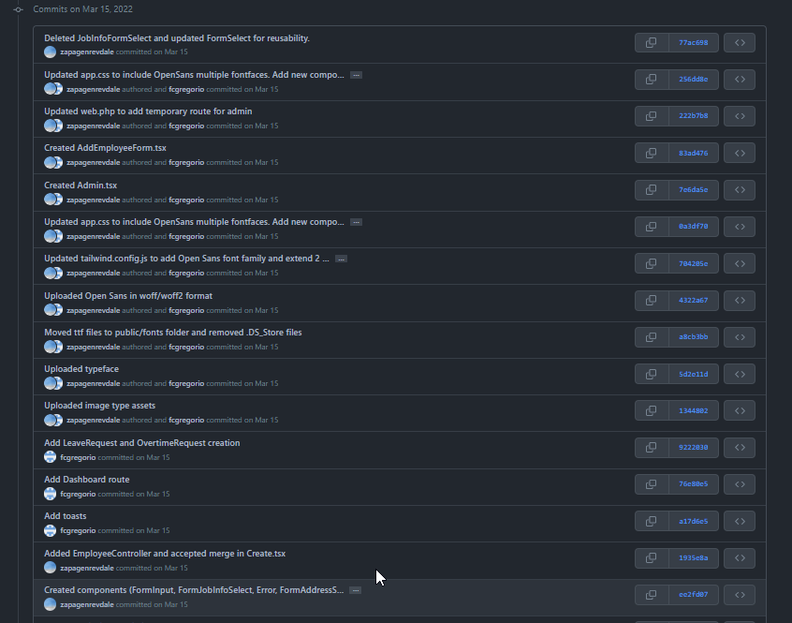

Committed tasks available on GitHub by March 15, 2022

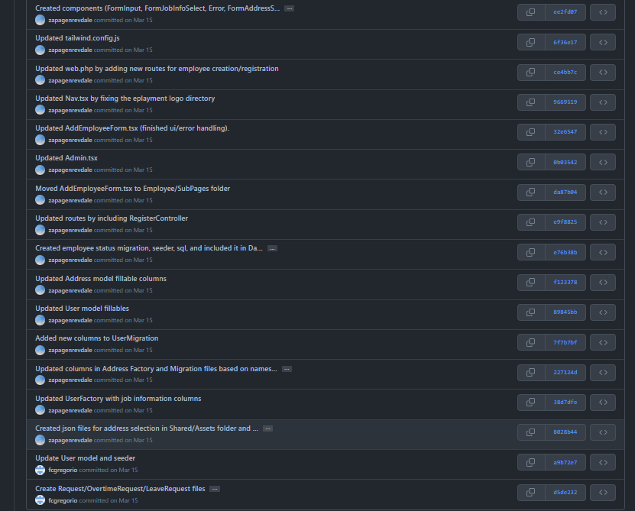

Committed tasks available on GitHub by March 15, 2022

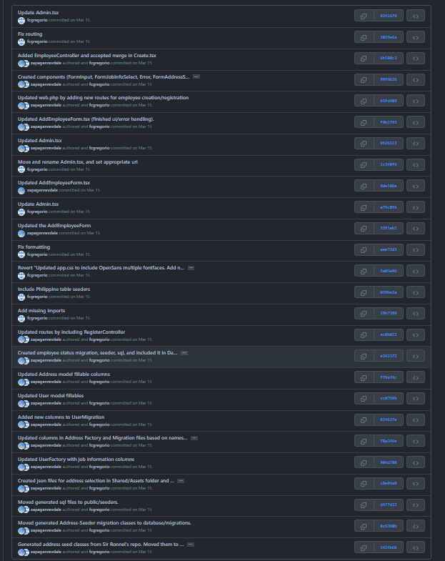

Committed tasks available on GitHub by March 15, 2022

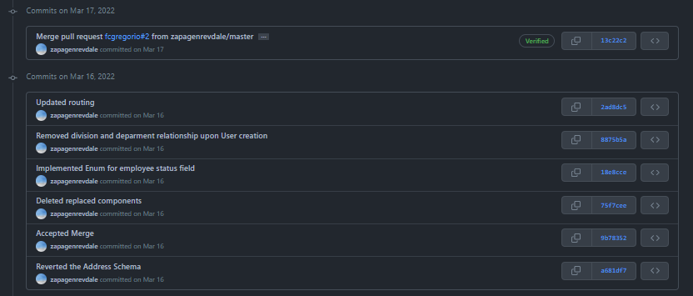

Committed tasks available on GitHub by March 17, 2022

### Week 4: March 21, 2022 – March 25, 2022

STUDENT NAME: Genrev Dale E. Zapa COMPANY: Eplayment Corporation PROGRAM: BS Computer Science

|  |  |  |  |
| --- | --- | --- | --- |
| DAY | **DATE** | **DAILY ACCOMPLISHMENTS** | **NO. OF WORKING HOURS** |
| Monday | March 21, 2022 | * Updated UserFactory so that the seeded User attributes such as division_id, department_id, and position_id corresponds to what's available in the database already. * Implemented Profile Details section of the Employee/Show page. * Updated the EmployeeController show() so that all the data needed in Employee/Show page is passed accordingly. * Minor updates on app.css, Layout.tsx, and tailwind.config in relation to updates on design * Commmit staged changes and pushed changes on Github (fork) * Daily Stand Up Meeting   Software/Tools used: PhpStorm, Laravel, MariaDB, Figma, Discord, Google Chrome, React, Typescript, Git, Github | 8 |
| Tuesday | March 22, 2022 | * Merge master branch into my Github fork. * Create pull request to master branch * Review comments and suggestions on the pull request. * Sprint Mu Retrospective and Demo of DOD * Studied Laravel Query Builder Documentation. * Daily Stand Up Meeting   Software/Tools used: PhpStorm, Laravel, MariaDB, Figma, Discord, Google Chrome, React, Typescript, Git, Github | 8 |
| Wednesday | March 23, 2022 | * Sprint Mu Review and Sprint Nu Planning with Devs * Implemented *edit* action (a function for user/employee data edit/update) on EmployeeController. * Resolve conversations on my pull request such as implementing resource route, removing unecessary abstraction of background image, and applying hint type based on resource convention. * Update UserFactory by fixing department-division heirarchy * Small updates EmployeeController based on the changes heirarchy.   Software/Tools used: PhpStorm, Laravel, MariaDB, Figma, Discord, Google Chrome, React, Typescript, Git, Github | 8 |
| Thursday | March 24, 2022 | * Review conversations and apply prettier formatting on the codes. * Rewrite EmployeeController edit structure by applying eager loading, implementing mutator, and use of proper casing on variables. * Rewrite Employee/Index.tsx based on the changes on EmployeeController. * Update, Position, and User models by adding Eloquent relationship * Daily Stand Up Meeting   Software/Tools used: PhpStorm, Laravel, MariaDB, Figma, Discord, Google Chrome, React, Typescript, Git, Github | 8 |
| Friday | March 25, 2022 | * Updated localities and regions json to match what's available on the seeded database for Philippine data address. * Commmit staged changes and pushed changes on Github (fork). * Reply and closed resolved conversations. * Refining updates on Employee: Show.tsx, Index.tsx, and EmployeeController * Daily Stand Up Meeting   Software/Tools used:PhpStorm, Laravel, MariaDB, Figma, Discord, Google Chrome, React, Typescript, Git, Github | 7 |

**TOTAL NO. OF HOURS**: 39

#### Week 4 Screenshots

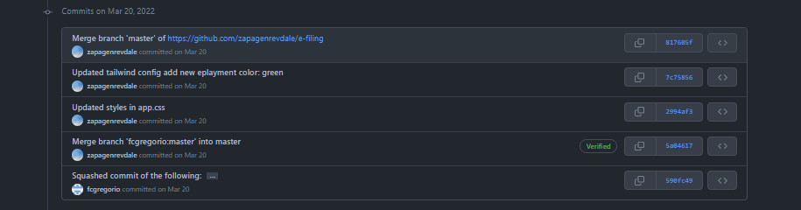

Committed tasks available on GitHub by March 20, 2022

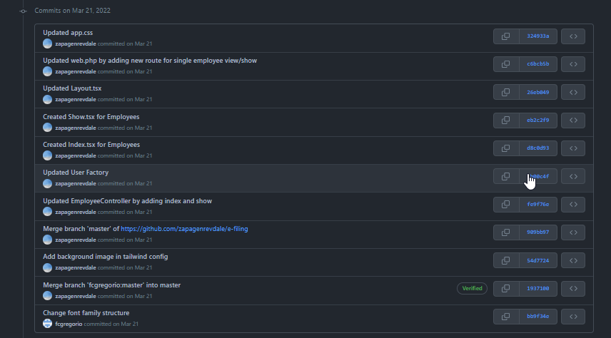

Committed tasks available on GitHub by March 21, 2022

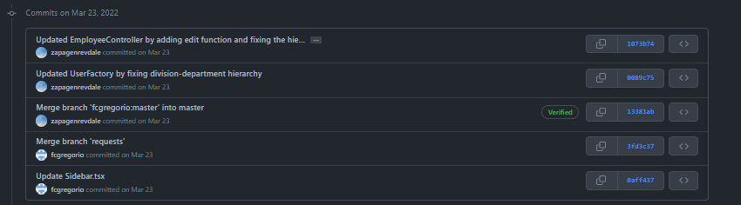

Committed tasks available on GitHub by March 23, 2022

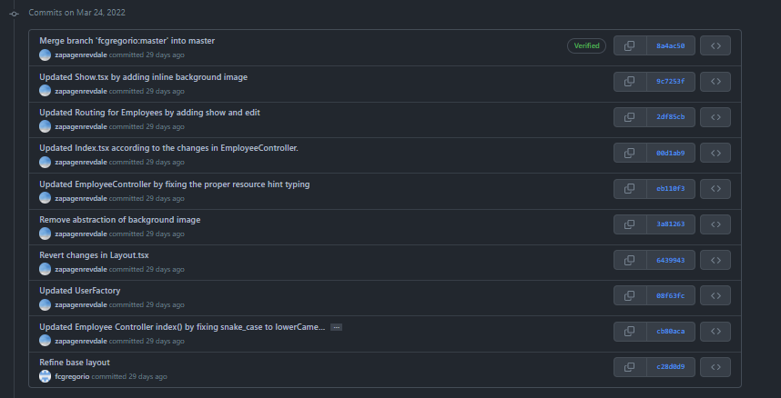

Committed tasks available on GitHub by March 24, 2022

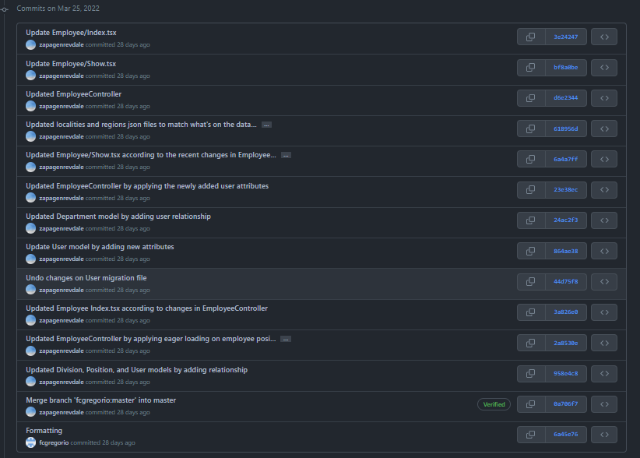

Committed tasks available on GitHub by March 25, 2022

### Week 5: March 28, 2022 – April 1, 2022

STUDENT NAME: Genrev Dale E. Zapa COMPANY: Eplayment Corporation PROGRAM: BS Computer Science

|  |  |  |  |
| --- | --- | --- | --- |
| **DAY** | **DATE** | **DAILY ACCOMPLISHMENTS** | **NO. OF WORKING HOURS** |
| Monday | March 28, 2022 | * Updated EmployeeController show by adding explicitly loading the address. * Implemented client side search of employees in Employees/Index.tsx page. * Improved css on employee indexing and division indexing * Commmit staged changes and pushed changes on Github (fork). * Daily Stand Up Meeting   Software/Tools used: PhpStorm, Laravel, MariaDB, Figma, Discord, Google Chrome, React, Typescript, Git, Github | 6.65 |
| Tuesday | March 29, 2022 | * Small code update (variable renaming) on EmployeeController * Merged master branch to forked repository. * Reviewed/studied co-intern updates on backend/frontend. * Daily Stand Up Meeting   Software/Tools used: PhpStorm, Laravel, MariaDB, Figma, Discord, Google Chrome, React, Typescript, Git, Github | 5.35 |
| Wednesday | March 30, 2022 | * Reformat and use svg on buttons pm Employees/Index.tsx * Studied headless UI (a javascript library) * Implemented headlesss UI dropdown button on Employee/Index.tsx * Daily Stand Up Meeting   Software/Tools used: PhpStorm, Laravel, MariaDB, Figma, Discord, Google Chrome, React, Typescript, Git, Github | 7.25 |
| Thursday | March 31, 2022 | * Continue implementing client side sorting algorithm on employee indexing. * Implemented client side sorting algorithm alphabetically (A-Z,Z-A) and employee starting date (newest, oldest). * Daily Stand Up Meeting   Software/Tools used: PhpStorm, Laravel, MariaDB, Figma, Discord, Google Chrome, React, Typescript, Git, Github | 6.25 |
| Friday | April 1, 2022 | * Studied pagination React/Laravel * Updated Employees/Index.tsx by updating the css and adding link on buttons. * Added breadcrumbs on the Employees/Index.tsx * Brownbag Session by Michael: Creating API Endpoints   Software/Tools used:PhpStorm, Laravel, MariaDB, Figma, Discord, Google Chrome, React, Typescript, Git, Github | 7 |

#### Week 5 Screenshots

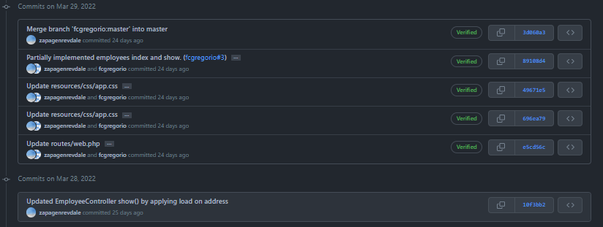

Committed tasks available on GitHub by March 29, 2022

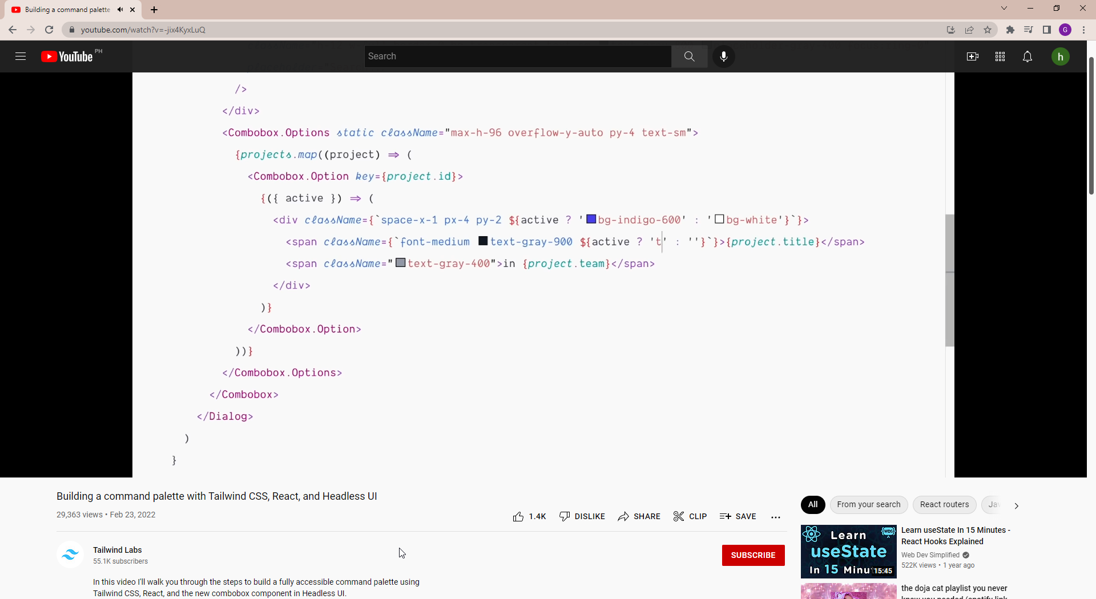

Studied Headless UI

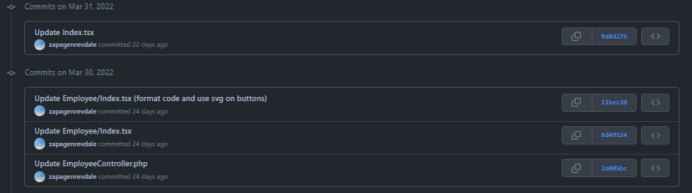

Committed tasks available on GitHub by March 31, 2022

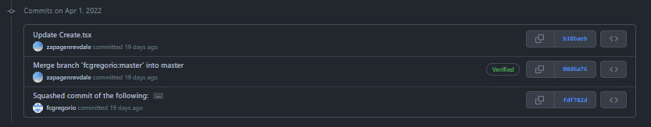

Committed tasks available on GitHub by April 1, 2022

### Week 6: April 4, 2022 – April 8, 2022

STUDENT NAME: Genrev Dale E. Zapa COMPANY: Eplayment Corporation PROGRAM: BS Computer Science

|  |  |  |  |
| --- | --- | --- | --- |
| DAY | **DATE** | **DAILY ACCOMPLISHMENTS** | **NO. OF WORKING HOURS** |
| Monday | April 4, 2022 | * Small code update (variable renaming) on EmployeeController * Created Employees/Edit.tsx (a page where the admin can edit employee details) * Created EmployeeController edit functionality (a function that provides acces to the edit employee page) * Daily Stand Up Meeting   Software/Tools used: PhpStorm, Laravel, MariaDB, Figma, Discord, Google Chrome, React, Typescript, Git, Github | 8 |
| Tuesday | April 5, 2022 | * Integrated EmployeeController edit and Employees/Edit.tsx so that the data can be passed from backend to frontend * Commmit staged changes and pushed changes on Github (fork). Fetched and merched changes from the master branch. * Sprint Mu Review and Sprint Nu Planning with Devs   Software/Tools used: PhpStorm, Laravel, MariaDB, Figma, Discord, Google Chrome, React, Typescript, Git, Github | 6.85 |
| Wednesday | April 6, 2022 | * Studied/reviewed fetched changes from master branch. * Updated web.php by adding employees/update route. * Daily Stand Up Meeting (Presentation of DOD) * Created EmployeeController update functionality (a function that updates changes upon editing from Employees/edit page)   Software/Tools used: PhpStorm, Laravel, MariaDB, Figma, Discord, Google Chrome, React, Typescript, Git, Github | 2.5 |
| Thursday | April 7, 2022 | * Updated web.php by adding employees/update route. * Created EmployeeController update functionality (a function that updates changes upon editing from Employees/edit page) * Created Request/UpdateEmployeeRequest.php file which validates requests from the Employees/Edit page. * Updated AddressFactory so that the seeded address references to the address data available in the database. * Commit staged changes and pushed changes on Github (fork). * Daily Stand Up Meeting   Software/Tools used: PhpStorm, Laravel, MariaDB, Figma, Discord, Google Chrome, React, Typescript, Git, Github | 5.8 |
| Friday | April 8, 2022 | * Implemented "luxon" to transform dates into ISO format on Employees/Edit.tsx * Created button and modal for employee deletion/archive using headless UI. * Commmit staged changes and pushed changes on Github (fork). * Fetched and merched changes from the master branch. * Created pull request to the master branch. * Daily Stand Up Meeting   Software/Tools used: PhpStorm, Laravel, MariaDB, Figma, Discord, Google Chrome, React, Typescript, Git, Github | 2.5 |

**TOTAL NO. OF HOURS**: 25.65

#### Week 6 Screenshots

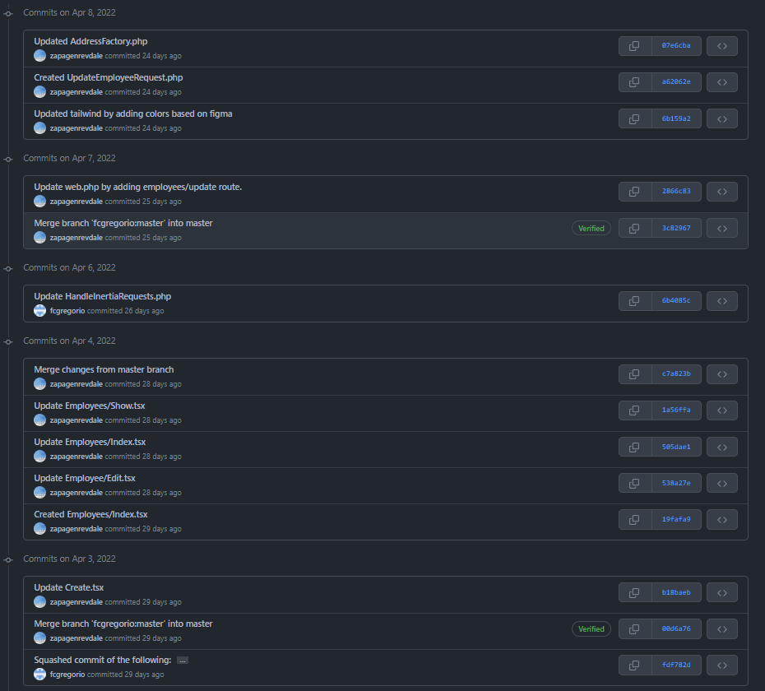

Committed tasks from April 2 to April 8, 2022

### Week 7: April 11, 2022 – April 15, 2022

STUDENT NAME: Genrev Dale E. Zapa COMPANY: Eplayment Corporation PROGRAM: BS Computer Science

|  |  |  |  |
| --- | --- | --- | --- |
| DAY | **DATE** | **DAILY ACCOMPLISHMENTS** | **NO. OF WORKING HOURS** |
| Monday | April 11, 2022 | * Updated EmployeeController by adding destroy action (a function that archives a user) * Created Employees/Destroy.tsx (a front end component that archives an employee) * Updated User model by adding archived_at attribute. * Update web.php route for employee archive/destroy. * Daily Stand Up Meeting   Software/Tools used: PhpStorm, Laravel, MariaDB, Figma, Discord, Google Chrome, React, Typescript, Git, Github | 4.65 |
| Tuesday | April 12, 2022 | * Fetch upstream changes from master branch and reviewed those changes. * Implemented Pagination on employee indexing. * Updated employee search from client-side to server-side * Updated employee sorting from client-side to server-side * Daily Stand Up Meeting   Software/Tools used: PhpStorm, Laravel, MariaDB, Figma, Discord, Google Chrome, React, Typescript, Git, Github | 7.25 |
| Wednesday | April 13, 2022 | * Updated EmployeeController/Index with respect to the implementation of pagination, server-side sort and searching. * Updated EmployeeController by applying run time loading to append custom User attributes * Daily Stand Up Meeting   Software/Tools used: PhpStorm, Laravel, MariaDB, Figma, Discord, Google Chrome, React, Typescript, Git, Github | 2.75 |
| Thursday | April 14, 2022 | HOLIDAY |  |
| Friday | April 15, 2022 | HOLIDAY |  |

**TOTAL NO. OF HOURS**: 14.65

#### Week 7 Screenshots

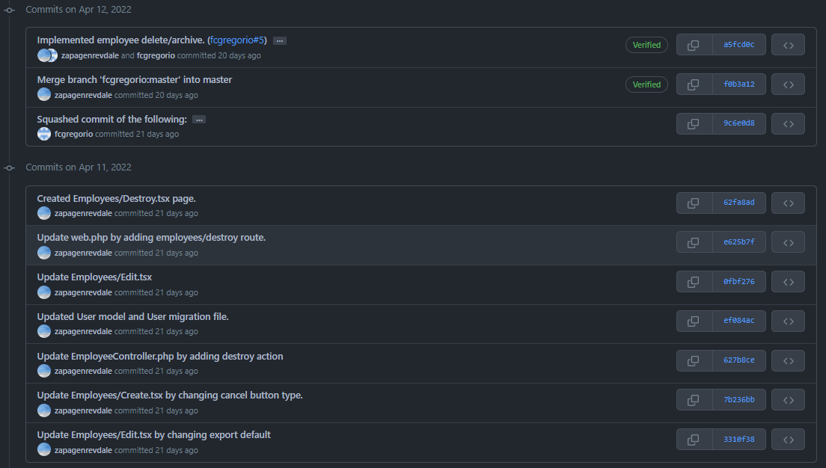

Committed tasks from April 11 to April 12, 2022

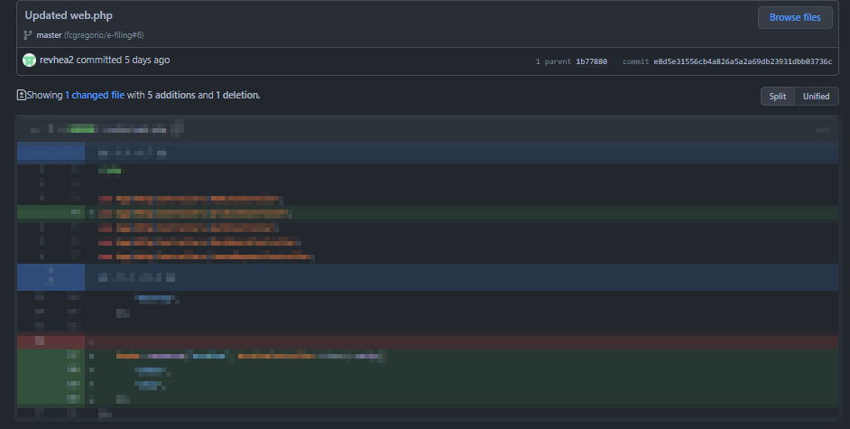

Updated web.php according to add the new routes.

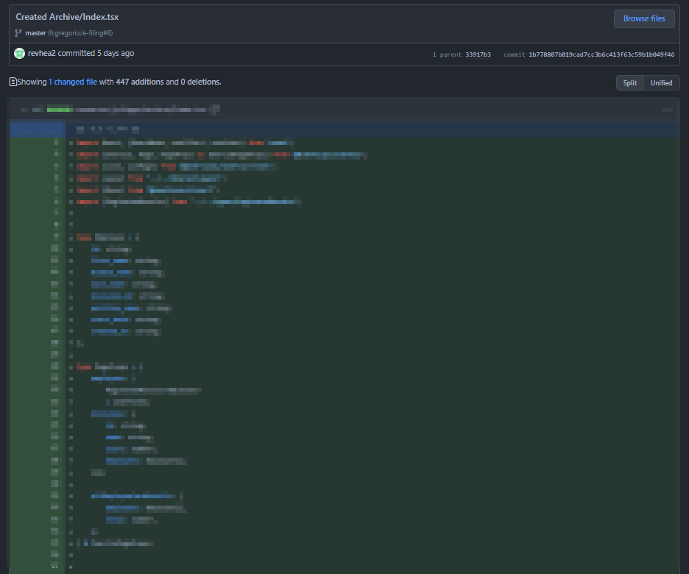

Implemented archived user indexing on front end.

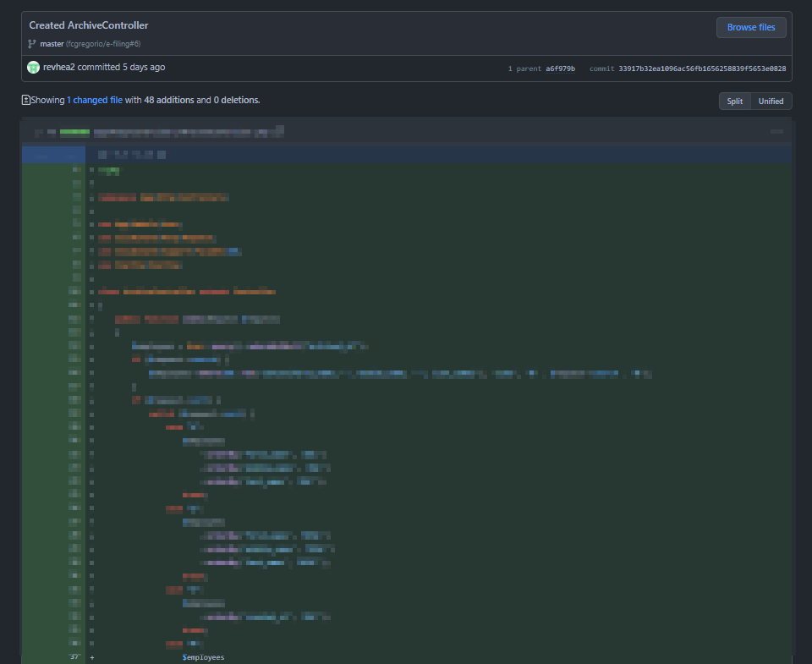

Implemented archived user indexing on backend.

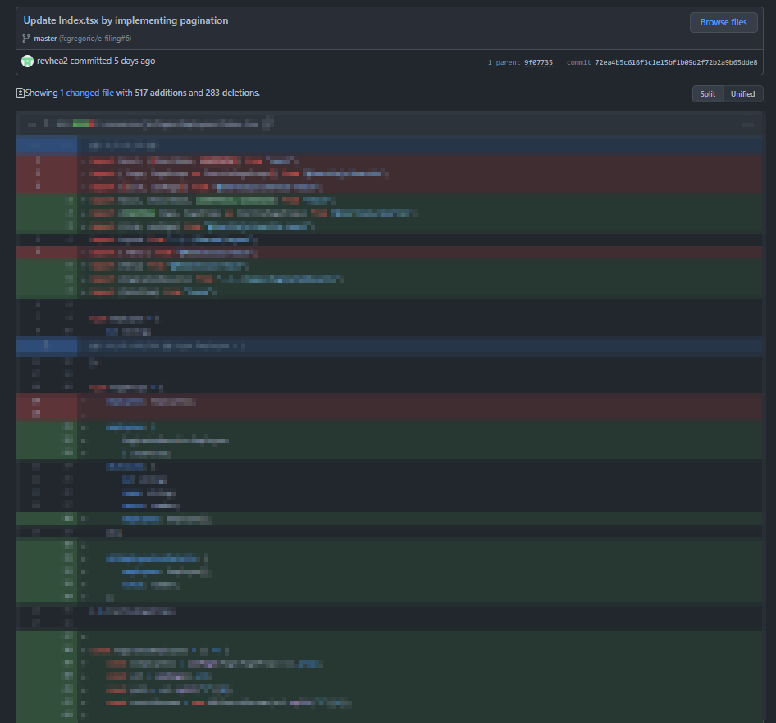

Implemented pagination on employee indexing.

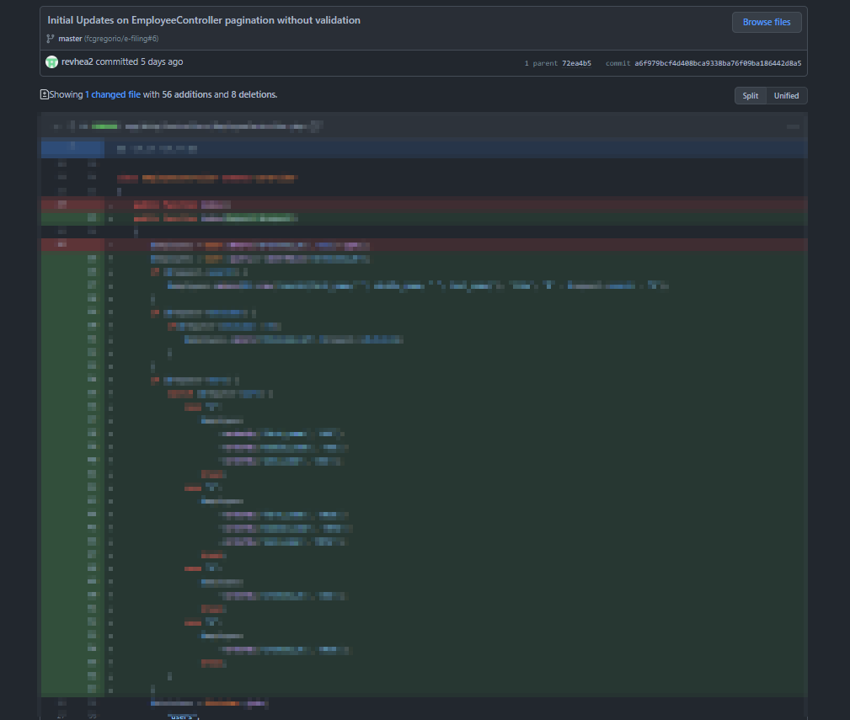

Implemented sort, search, indexing through requests on backend.

### Week 8: April 18, 2022 – April 19, 2022

STUDENT NAME: Genrev Dale E. Zapa COMPANY: Eplayment Corporation PROGRAM: BS Computer Science

|  |  |  |  |
| --- | --- | --- | --- |
| DAY | **DATE** | **DAILY ACCOMPLISHMENTS** | **NO. OF WORKING HOURS** |
| Monday | April 18, 2022 | * Added validation to requests employee indexing both client and server side. * Committed all staged changes and pushed to GitHub repository. * Daily Stand Up Meeting   Software/Tools used: PhpStorm, Laravel, MariaDB, Figma, Discord, Google Chrome, React, Typescript, Git, Github | 2.05 |
| Tuesday | April 19, 2022 | * Sprint KSI Retrospective and DEMO of DOD   Software/Tools used: PhpStorm, Laravel, MariaDB, Figma, Discord, Google Chrome, React, Typescript, Git, Github | 5 |

**TOTAL NO. OF HOURS**: 7.05

#### Week 8 Screenshots

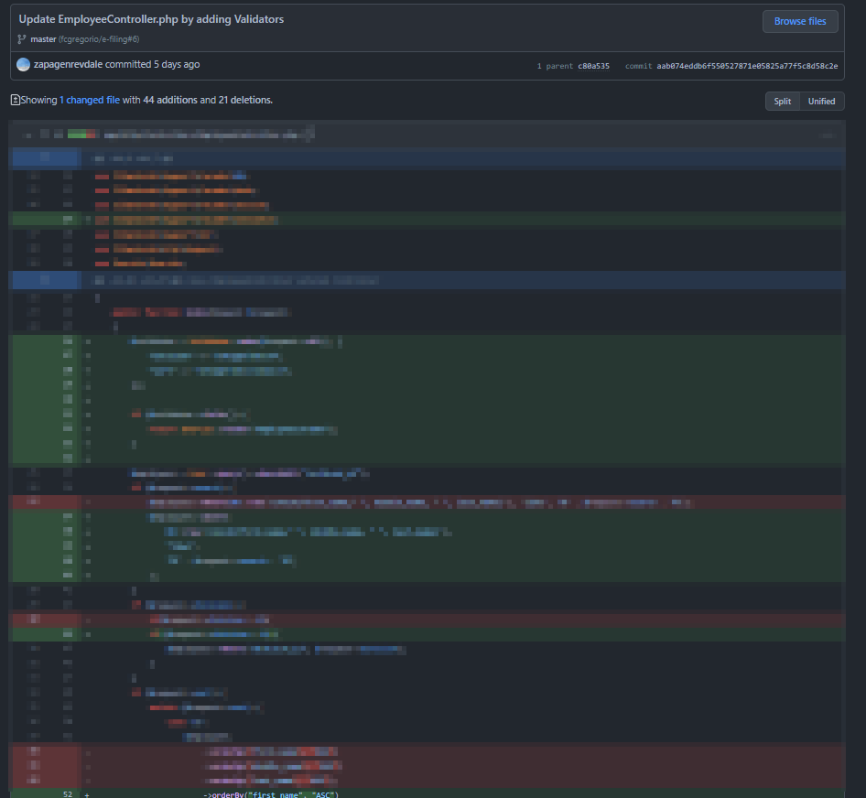

Added request validators to the employee controller index action.

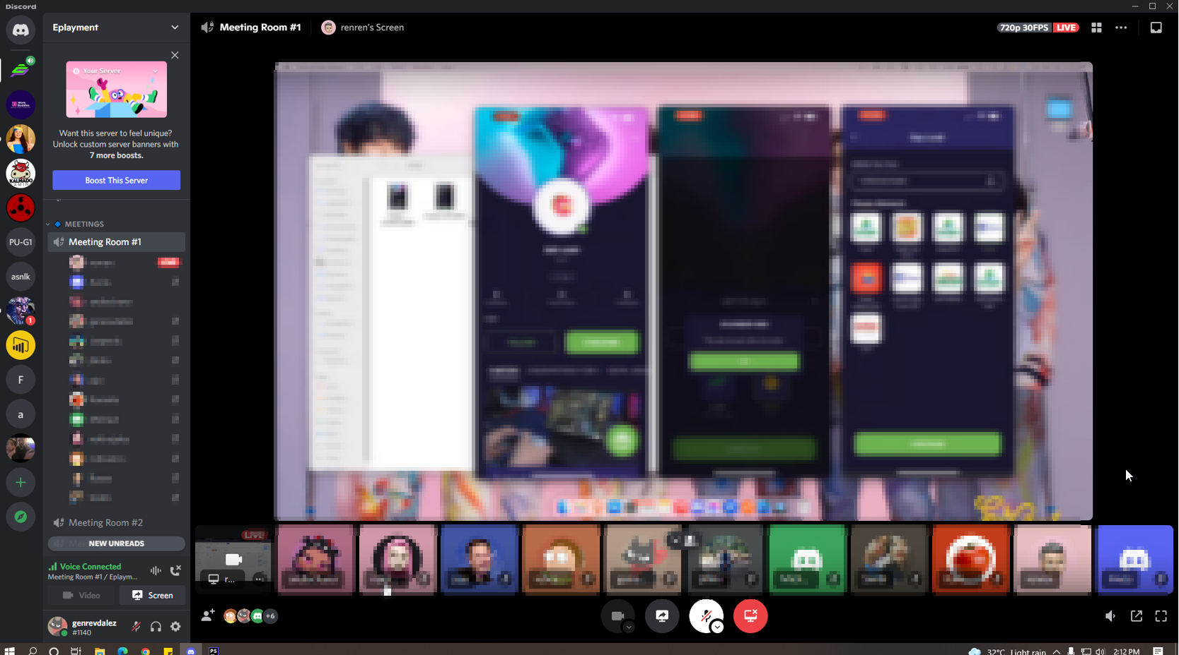

My last sprint (KSI) retrospective and demo of DOD.

### Monthly Work Activities 1: February 28, 2022 – April 1, 2022

STUDENT NAME: Genrev Dale E. Zapa COMPANY: Eplayment Corporation PROGRAM: BS Computer Science

|  |  |  |  |
| --- | --- | --- | --- |
| WEEK NUMBER | **DATE** | **WEEKLY ACCOMPLISHMENT** | **NO. OF WORKING HOURS** |
| 1 | Feburary 28, 2022  to  March 4, 2022 | * Studied laravel 8 Framework from Laracasts * Studied Docker * Studied Tailwind * Studied Inertia * Studied React Typescript * Set up development environment | 40 |
| 2 | March 7, 2022  to  March 11, 2022 | * Studied the mockup of E-filing (project assigned to me) in Figma * Created/Analyzed ERD for E-filing * Created the layout page consisting of navbar and sidebar * Uploaded Figma assets to project from Figma * Created the add employee form (front end only) * Pulled Philippine Geography from our senior engineer's and supervisors’ repository * Integrated the add employee form to the backed | 40 |
| 3 | March 14, 2022  to  March 18, 2022 | * Implemented route for displaying add employee form from backend * Updated factory models e.g., Users, Address * Implemented employee status using enum * Updated user migration tables * Implemented user instance creation * Updates on designs on account creation page * Created user indexing page * Implemented user indexing on backend * Implemented basic search functionality on indexed users * Created profile details page layout * Implemented show user details on backend | 39.1 |
| 4 | March 21, 2022  to  March 25, 2022 | * Updated factory models on users * Implemented profile details section * Updated show user details on backend * Optimized backend controller for users * Updated Philippine geography data | 39 |
| 5 | March 28, 2022  to  April 1, 2022 | * Optimized backend controller on users by applying eager loading * Implemented client-side search and sort full functionality in employee indexing * Reformat images using SVG * Learned Laravel pagination * Studied and implemented components using Headless UI * Added breadcrumbs on create and edit user page | 32.5 |

**TOTAL NO. OF HOURS**: _____190.6_____

#### Monthly Work Activities 1 Screenshots

**WEEK 1**

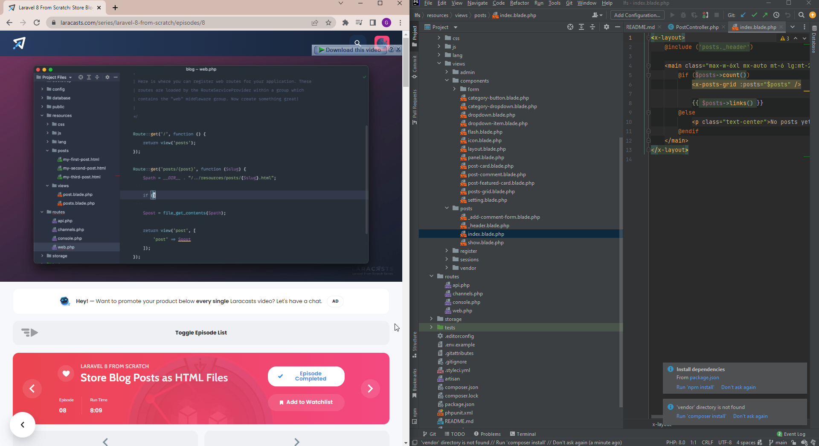

Studying Laravel through Laracasts

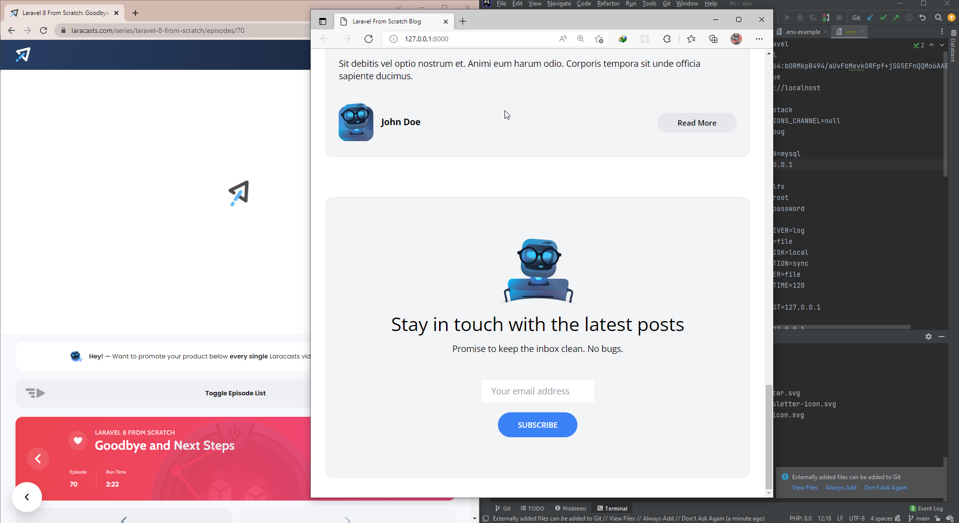

Finished Laracasts: Laravel 8 from scratch



Setup Environment for Docker



Use of WSL2 for Docker



Studied Tailwind css



Studied Inert.js



Studied React.js/tsx with Laravel and Inertia

**WEEEK 2**



Designed ERD



Studied documention of Spati Laravel-Permission



Committed tasks available on GitHub by March 9, 2022



Committed tasks available on GitHub by March 10, 2022

**WEEK 3**



Committed tasks available on GitHub by March 15, 2022



Committed tasks available on GitHub by March 15, 2022



Committed tasks available on GitHub by March 15, 2022



Committed tasks available on GitHub by March 17, 2022

**WEEK 4**



Committed tasks available on GitHub by March 20, 2022



Committed tasks available on GitHub by March 21, 2022



Committed tasks available on GitHub by March 23, 2022



Committed tasks available on GitHub by March 24, 2022



Committed tasks available on GitHub by March 25, 2022



Committed tasks available on GitHub by March 21, 2022



Committed tasks available on GitHub by March 23, 2022



Committed tasks available on GitHub by March 24, 2022



Committed tasks available on GitHub by March 25, 2022

**WEEK 5**



Committed tasks available on GitHub by March 29, 2022



Studied Headless UI



Committed tasks available on GitHub by March 31, 2022



Committed tasks available on GitHub by April 1, 2022

### Monthly Work Activities 2: April 4, 2022 – April 19, 2022

STUDENT NAME: Genrev Dale E. Zapa COMPANY: Eplayment Corporation PROGRAM: BS Computer Science

|  |  |  |  |
| --- | --- | --- | --- |
| **WEEK NUMBER** | **DATE** | **WEEKLY ACCOMPLISHMENT** | **NO. OF WORKING HOURS** |
| 6 | April 4, 2022  To  April 8, 2022 | * Implemented Edit Employee functionality in backend * Implemented Edit Employee interface for front end * Optimized the controller for Employee update. * Updated the front end for employee edit using luxon api. | 25.65 |
| 7 | April 11, 2022  to  April 13 | * Implemented Delete Employee functionality in backend * Implemented Delete Employee interface for front end * .Implemented basic pagination on employee indexing | 14.65 |
| 8 | March 14, 2022  to  March 18, 2022 | * Added validation for employee indexing such as pagination, search, and sorting. * Sprint KSI Retrospective and DEMO of DOD | 7.05 |

**TOTAL NO. OF HOURS**: _____47.35_____

#### Monthly Work Activities 1 Screenshots

**WEEK 6**



Committed tasks from April 2 to April 8, 2022

**WEEK 7**



Committed tasks from April 11 to April 12, 2022



Updated web.php according to add the new routes.



Implemented archived user indexing on front end.



Implemented archived user indexing on backend.



Implemented pagination on employee indexing.



Implemented sort, search, indexing through requests on backend.

**WEEK 8**



Added request validators to the employee controller index action.



My last sprint (KSI) retrospective and demo of DOD.

* + 1. **PERSONAL EVALUATION OF THE TRAINING PROGRAM**

**Personal Evaluation of the Training Program**

## Professional Learning and Development Achieved

During my stay at PVAO, I learned many things. One of those is to become a professional in terms of appreciating all the people around us, do not expose the information of the company, be honest and trustworthy always because this quality will serve us to become a more good person. Other learning and I have developed in my qualities are being fair to all I did, especially in my assigned tasks, if someone needs help, helped them and not to discriminate, respect each other all the time. Data privacy also is also learned and developed while in my training program that does not disclose anything in public all the information about the company. Protect the company assets and do not use any resources without asking permission to them.

## Modern Techniques, Skills and Tools Used/Learned

My OJT program probably is the shortest yet most insightful event so far as an aspiring computer scientist. It gave me a very good view of what I will be doing in the work field. I realized that communication is a major factor for a successful task. I learned that there are multiple types of people who you will be able work with: some quiet, some vocal, some approachable, some are difficult to communicate with and so on. Experiencing what its like to be in a work field made me realize that I am nothing special. It is true that during my college life I have been garnering good grades and awards, but it did not really matter when faced with big tasks and obstacles you have never faced before. As such, the only way I can survive is to rely on experienced people and ask them insights that might help you solve the problem or complete the tasks assigned to you. When it comes to the technical tools, I learned JIRA which is project management tool that we use to follow the agile methodology using the scrum framework. I also learned Docker and WISL which is a container-based framework that allows me to create a clean empty environment for the application my co-intern and I will create. Additionally, is PHP which is the programming language used for the LARAVEL framework — the framework we used in building our backend. Moreover, we used TypeScript as programming language to implement the pages we need to render on front end using the React Framework. The client and server side are connected using a tool called Inertia.js which is a "modern monolith" that integrates the backend and front into a single port. I also used Table Plus as a tool to check what's stored in the database in which I decided to run using MariaDB — a very popular open-source relational database tool.

In retrospect, I improved my problem-solving skills, analytical skills, communication skills, and presentation skills. Furthermore, I also learned how a startup business work starting from fundraising and to other complicated things. The people on the company that I worked as an intern with are friends with each other, and I think that's the most important thing that I learned in this company. Because if you are a friend, you will be willing to give and listen to criticisms — be it constructive or just purely practical.

## Equipment, Machinery, Testing Apparatus, etc., Handheld

## In our office, our supervisor entitled us to use a computer for the whole OJT period. Our machines are identical and contain the same specifications that can run multiple software for office use. We were also given permissions on borrowing devices for testing the applications that we made to check device compatibility. Developing Android and iOS applications at the same time needs a high-end computer, but they only have separate machines for each platform. I also had difficulty in using my keyboard as it needs to be pressed hard to register the key that I pushed. Nonetheless, I managed the impediment and proceeded in developing applications usually.

## Experiences with the Company Personnel Involved in the Training

From applying up to the conclusion of my OJT program, all of the company personnel have been nice to me. The first time I contacted the company was through an email to their HR, sir Dian Reyes. His response was fast, it was morning that I sent an email of application and then I got his reply at the afternoon. Additionally, my papers were swiftly checked and processed (my documents were ready at that time) the same day I applied.

At the start of my OJT, I have already been handed to our project manager, Andrea Echano. She briefly introduced me about the company workflow and core values. At the end of the day, she provided me a video of her explaining the agile methodology, specifically the scrum framework. She was responsible for assigning me tasks per sprint. Honestly, I think she has been a very good project manager, very diligent and have strict upbringing, however, she is at the same time patient, understanding and cheerful. I think the reason why I was able to keep with my tasks was because Andrea have always been directing me and reminding me every day what task I should do to fulfill my role as their intern.

My first task was to study and analyze a mockup on Figma. There I got to meet Noreen Rojales, the Lead UI/UX designer of the company. There were several lapses on the design that they provided for us to create the application called E-Filing. The lapses include inconsistency in design, lacking information, among others. Upon finding these lapses, I left comments and they were immediately attended. She was very timely, and she also taught me some basic design skills.

On the development part of the OJT, I met two supervisors: Ronnel Martinez, the backend supervisor as well as the co-founder of the company, and John Allen Chavez, the frontend supervisor. Most questions that I asked to sir Ronnel was about the standards in coding since we are building a software that they will really be using. Moreover, to increase the efficiency of the software I also asked sir Allen advice on front-end. Talking to them made me realize that I am still far from there. It did not discourage me but instead I was encouraged by the fact that I will someday be as good as them as long as I keep on learning. They were both dependable, patient, and knowledgeable about everything related to software developing so because of them I improved a lot.

Lastly, sir Naidas who is the CEO of the company. From the start to end, he has been encouraging me. He introduced to me their mission, vision, and goals. He was willing to provide me free lessons on fundraising and other things to start a company.

## Best Practices Used/Applied

As mentioned earlier, the company used the agile methodology using scrum framework. In facilitating the methodology, they used JIRA, an issue tracking software product useful for bug tracking, task assignment, and project management. JIRA can also enhance individual responsibility for different deliverables within a project and within a reasonable time. In the case of the Scrum framework, that reasonable amount of time is called a “sprint.” The duration of each sprint is two weeks, and the aim is to finish significant milestones, called “sprint goals,” by the end of the sprint. Additionally, we also have what they called “Daily Stand Up” which basically a daily progress report of the tasks at hand. At the end of the sprint, we have meetings for the demo of DOD (Definition of Done) and the day after is the sprint retrospect which basically us looking back to the lapses and shortcomings, i.e., backlogs from the previous sprint and planning for what will be the issues or tasks that will be given to us developers.

Another best practice that I applied is the use of address schema. My supervisor provided me a documentation of standard schemas used when designing the backend part of the software. Also, we used a versioning tool called Git where we saved an online repository on GitHub. I had to learn and apply the standard way of writing Git commits and pull requests.

The best practice that I really took into heart is coding based on documentation. Most of the time, I just rely on my own way of coding. However, there are standards to be followed and that is for example in the Laravel framework—the Laravel 9 documentations. I realized that it is not enough just to be able to do the task, but I must be able to do the tasks in such a way that it is readable and has documentation supported to it.

1. **Discipline Related Solutions Integrated into the Company**

In the company that I’ve internship with, OJT students were required to learn first the company’s core values, vision, mission, methodology, etc. In my case, the CEO of the company, sir Naidas, personally shared the company’s goal, services, roadmap, and some of the regulations that the company follows such as National Privacy Commission (NPC), Know-Your-Customer (KYC), and Operator of Payment Systems (OPS). It was implanted to us that just as the company itself follows the regulations, we should as part of the company should follow the rules. Since, we follow the agile methodology under scrum framework, we are required to regularly give updates on the tasks we are currently working with. Needless to say, we should not be late during this session/meeting we call the Daily Stand Up. In terms of programming, we were told to provide comments as much as possible so that the functions that we created will be easily reviewed. Also, we had to follow a strict implementation of versioning. This means that if I committed a major change in the code, I should make a sort of checkpoint so that when something goes wrong, we can trace back easily the errors and bugs.

At the end of the sprint, we basically demo our deliverables. Since, I am just an intern, I had to present my works at the end of the meetings. During the meeting we were required to turn off our microphone while the presenter is still speaking. After that we basically speak only after virtually raised our hand, the project manager will then decide whether they would allow us to speak by questioning or giving questions to the presenter.

One of the disciplines that I like in the company is their transparency on their tasks. This means that I too can see the tasks the others are working, excluding of course the part where customer details and information are involved. This makes it easier for the project manager to check whether I am doing my part since the project manager can see the commits that is saved in the online repository.

1. **Strong Points**

The strong points of the company are the friendly environment, strict implementation of rules, and their dedication to provide quality service. Since, they only accepted two interns it was easy for them to track our activities. The tasks were actually not meant for interns but since our skills were gauged, they agreed that we are capable of developing a software that they will use. That software is called E-Filing, it is a software that allows them to check their leave credits and perhaps file a leave request. The software itself was complex, there were multiple types of users, so we have to design the software in such a way that users are only capable of doing what they are permitted. For example, the project manager can either accept or decline filed leave requests. There were multiple features such as other worker could see who are only during certain date in the calendar, who are available and who are not during the day/month/week.

By providing us these challenging tasks, I was able to deeply enhance my skills. It pushed me to study certain practices such as basing the codes in the documentation of the framework that we were using. The architecture and flow of the software itself was very difficult for me, therefore, in such cases I would have to ask for the supervisor guidance so that I could avoid problems once we implement the designs.

During the implementation phase, communicating was the least problem because we are in online setup which means that anytime I can ask my co-intern or supervisor when there were tasks that I cannot solve by my own. Most of the time, I was able to complete the tasks although it required for me to study for hours and hours the documentations. Lastly, one of the strongest points in my task is that I was able to really get a hands-on of what it is like to be a software developer. They did not treat us just like a newbie and they also have a high expectation on us. In order to go beyond their expectation, I had to think wisely and work double time which is the reason I am a better software engineer now than I was before entering the internship program.

## Weak Points and Suggested Solutions

I personally think that the company itself was perfect and since I am not a full-time employee, I cannot entirely tell the disadvantages of the company. However, when it comes to my own weak points, during the course of the OJT program I solved a lot of them. Before, I used to rely on my analytical skills to solve the problem. I do not usually check the internet nor the documents of the framework that I am using. Apparently, this is a very bad practice, although it is nice that I am able to solve problems on my own without the use of external tools, sometimes the solution is already available on the internet. The solution could be in a form of snippet, documentation, or just plain concept. The idea is that my solution might not be optimal compared to the ones available on the internet. Hence, instead of solving it on my own first, the order should be checking the documentation, check the concept behind the documentation, check for existing records asking for the sample problem on the internet, and then decide whether I should take their advice or implement the solution on my own.

Another weakness is that I cannot clearly convey my thoughts. At the end of the sprint, we were required to present a demo of the tasks we completed. My problem is that even though I have a lot of features added, when it comes to explaining to them, I don’t seem to showcase them all the tiny details. I think it is because I feel like small features added are not supposed to be presented as they aren’t typically interesting, and I am afraid that it might not be appreciated at all. The solution to this to be more confident of my work.

Lastly, I really rely on myself most of the time. The internship program allowed me to give myself some slack and just simply rely to others sometimes. I learned a lot of techniques because of it. I am now not ashamed on asking for help, because it is better to be embarrassed once than to be ignorant forever.

* + 1. **RECOMMENDATIONS**

**Recommendations**

1. **Potential of the Company as a Training Ground**

* Availability and Appropriateness of Facilities, Equipment, and Machinery

I would like to recommend the Information Technology Services Office (ITSO) to the future students who will enrol in an On-the-Job Training course because they have all the resources you needed to become an efficient OJT student. They have a high-quality facility wherein you will be comfortable when working inside their department, their equipment is readily available for development, and they will also provide workstations for the whole internship period.

* Company Personnel Cooperation

Most of the personnel in their department are friendly and approachable. They will guide you in every step you make to ensure that you are on the right track in doing your tasks. They will keep you motivated and inspired to boost your confidence in doing the said task. Also, they would always provide assignments that will help you explore more about your profession to prevent yourself from limiting your capabilities.

1. **Duration of Training**

The duration of the training is enough for learning new techniques, tools, and libraries that can be a good foundation for entry-level programmers in applying for a job in an industry. In every task given to us, they gave us ample time to develop and finish the stated assignment on or before the due date. After completing the job, you can make use of the remaining time from a task to study other techniques and implementations that can be useful for mobile application development to ease up the existing problems and be more productive coding without constant errors and bugs.

1. **Suggestions for the Improvement of the Training Program**

As one of the pioneers of OJT under online learning, I felt privileged because, in majority, the OJT has been successful despite the work from home setup. This means that it is not necessary that we must do a face-to-face setup to experience what it’s like to be in a real-world workspace. Despite the statement, I also feel a bit unsatisfied, because even though I experienced wholeheartedly what it’s like to work in a company, having it virtual kind of limited the communication and bond which otherwise we could have done more if we were to have the face-to-face setup.

Nevertheless, the lessons that I have learned during the course of the training program were not depreciated. Having a work-from-home setup allowed me to spend more of my time studying the tools I need in order to finish my tasks anytime I want. The company that I worked with did not require us to strictly record the time and that is because they follow the agile methodology under the scrum framework. As long as the tasks are done during the end of the sprint, then nothing else technically matters.

My first suggestion for the improvement of the OJT program is to make the mock interview more personalized. Although I learned a lot from the mock interview, I felt like the questions weren’t exactly meant for me on a personal level. Because in my experience, the HR weren’t really asking those vague and broad questions but more of a personal and technical questions. Hence, my suggestion is to have another set of interviews in technical aspects. For example, in the computer science field, maybe a mock interview that asks us more technical questions such as algorithms and so on. This is the only way that we could not only have the ability to answer more general questions but also technical questions that are probably one of the most decisive aspects whether I pass or fail to enter the company.

Another suggestion is to get the faculty-in-charge involved in the student’s workplace. This is definitely a hard task especially if the instructor is already handful with other subjects. However, having the faculty-in-charge take part of the student’s activities even just once every two weeks will have a positive impact for the student and also in that way the instructor could check the credibility of the workspace the student is currently working in. This way, the instructor could gauge the student’s workload whether it is too hard for the student or too easy. If it is too easy, then the faculty-in-charge can ask the company to provide the student with more tasks so that the student wouldn’t stay idle for the whole day. On the other hand, if it is too hard and the instructor feels like the student is burdened then the instructor can ask the company to lessen the workload enough to make the student jump into being burnt out.

1. **Advice to Future On-the-Job Trainees**

Experiencing the first-hand the struggles and challenges of being an OJT trainee, I realized that there are several aspects that future On-the-Job trainees could consider before taking a company to go internship with.

The first advice I could give is to build a solid foundation or master the basics of the of the job you want to take. Sadly, some of my friends just took whatever is available for them which means that there is a huge chance that might have no idea what their tasks are. Selecting the job that you are really interested is critical if you want to have fun while learning/working. If you do not like the job, then it is just a burden for you. On the other hand, if you are interested with the tasks at hand, your biggest problem is whether you have the skills to accomplish it. In my experience, adjusting from one tool to another was the most infuriating part of OJT. But since I have a solid background on the basics of the software development, it was easy for me to adapt to tools, frameworks, and implementation techniques that are according to the standards of the company.

Another advice is to just ask. If you are stuck with a problem for hours already, perhaps you can start by asking your co-intern if they know about the problem you are trying to solve. If no one has any idea, then definitely you should ask the one who is supervising you. There is big chance that they have already experienced that problem before so asking them would not take too much of their time. However, you should be polite when asking. Tell them that they can answer your queries after their respective jobs are done, never hasten them because they are probably working much bigger and critical problem than you do.

Lastly, know the company. By knowing the company, you will already have something to discuss just on the first day. You can introduce yourself to them by flattering them about their vision and goals and how you want to be part of their team because of that. You want to build a relationship with your co-workers, hence, having an obvious and similar topic to talk with will help you starting.

* + 1. **SUCCESS STORY**

**TECHNOLOGICAL INSTITUTE OF THE PHILIPPINES *( KINDLY USE THE NEW FORM)***

**CAREER CENTER**

**SUCCESS STORY AND TESTIMONIAL**

|  |  |
| --- | --- |
| **Name:**  **Internship, Co-op or Research Site:**  Technological Institute of the Philippines – Quezon City, ITSO Building 6  **Program:** Information Technology  **Expected Graduation Year:**2018 | **Picture size 2x2** |
| ***Briefly describe your internship, co-op, research, or service-learning opportunity, including your day-to-day tasks, responsibilities, and assignments.***  During my internship period, they exposed me to the scrum methodology in which every morning we are required to share the progress of our deliverables. Every time I had free time and encountered problems with my assigned task I was able to seek and acquire new knowledge and solutions by studying Android Studio Libraries ( Retrofit and Realm), PHP Slim Framework, AI Concept for GagamBattle application, Core Data iOS version for iRaffle Application, Alamofire and Realm for Swift. I also learned a lot of libraries, techniques, and tools in mobile application development. Some of the significant libraries I managed to use Realm and Retrofit; Lastly, the tools that I used were Postman, Blender, Unity, and Xcode. I explored and mastered the basics of the stated tools to help myself progress and lessen the burden of producing a broad application. Lastly, I am proud to say that I was able to independently completed the modification of the following Projects:PickAPark Application API Conversion and Modification;• Updating iRaffle Application:RecyclerView Implementation; Testing and connection of TellerGinieHotel Application refactoring; Designed Evaluation Form and provided Sound Effects for GagamBattle Power-up Cards; Create Database Query, Add/Edit/Delete API, Dashboard, Text Animation and RecyclerView Implementation for Bloodletting Application. | |
| ***What have you enjoyed the most about your position or organization/company?***  The bonding and the relationship that we built during our period is the most enjoyable thing that I may share. We are inspired and motivated when we work, that is why we enjoy what we do. Most of the time, the fun factor is the reason why our outputs are well done. We do work with motivation and inspiration because without it; it is just slavery. | |
| ***What have you gained from your experience that you could not have gained from another opportunity?***  I gained a lot of ideas and techniques from my position. They introduced different tools, methods, and libraries, and most of them gave me ideas for creating solutions to the problems that I had been confused for so long. Some libraries were very helpful in application development, explicitly referring to Retrofit, Alamofire, and Realm, including Database Addition, API Integration, and UI/UX Library Implementation. I also learned how to implement Model-View-Presenter (MVP) Architecture in a project; it eliminates confusion for future developers who will handle the project that you managed. It is a best practice especially when you work in an industry. | |
| ***What advice would you give to another student***  For incoming OJT students, I would suggest choosing the track they’re comfortable with as it can unleash the potential that they possess. It can also improve their skills all throughout the training. Also, be open to any tasks given by your supervisor as it can help you grow and develop yourself to be flexible in task execution. Choose to work with any profession to enhance your skills in each field. | |
| ***How do you see your experience as meaningful? This might involve skills you’ve gained, information you’ve learned, mentors you’ve connected with, or projects you’ve completed.***  The experience and knowledge that I have acquired is an essential foundation for developing applications in the industry. The implementations and libraries that I had learned from my mentors can be used for future application development as it is a core foundation for developing applications that are accessed by multiple users in multiple instances. My mentors, supervisors, and co-workers had influenced me a lot; they became my motivation, inspiration for learning new things and completing all the assigned tasks. They contributed a lot to the development of my skills, and I’m thankful that they are my mentors and supervisors. | |
| ***Please provide a short quote about what you liked most about your position / earning internship credit / the internship placement process.***  I earned a lot of knowledge and experience all throughout the tasks that I had performed. I had fun because the position that they gave to me was my expertise, I didn’t experience any problem at all as it is my primary skill and I am comfortable with it. Earning “trust and sharing” knowledge with my co-trainees is the most important thing that happened during my internship period. | |

* + 1. **REFLECTIVE JOURNAL**

**Reflective Journal**

***My OJT Hunting Experience and My Experience in OJT***

When I started looking for a company, I went around metro manila and saw more than a dozen companies are open for On-the-Job Training (OJT). I called and asked for the requirements that they need when we apply as an OJT student. We visited elsewhere to find companies that are open for OJTs; these areas are Eastwood, Ortigas, and Banaue. Most of the companies we have visited have resumed our resumes to quickly process our request to apply as an OJT student to their company. However, most of the companies we have sent our resumes have not contacted us since we have been at the same time getting ahead and receiving them. We tried so many times to submit to our resumes to different companies because the deadline is near.

We are pleased to post our OJT Faculty-in-charger for new slots departments within our school. So we no longer wasting time and we are quick to apply ITSO soon. We were interviewed and looked at our portfolio to see if we were qualified for the OJT application developers, they were looking for their planned projects. And finally, we accepted, and we started our actual OJT work.

When we started our first day at ITSO, our supervisor instructed us to set up our computers and install necessary tools and programs in the development of mobile applications. And there we started our journey and discovered new things in our profession. The ITSO family welcomed us wholeheartedly, and as part of a family, we were joined to the Christmas party and enjoyed its pagination with other employees.

After some work, the tasks that they gave us are more challenging. Well, the duties that are given to us today are to improve our weaknesses. Not only do we maintain a single profession, but we are also aware of other things for the chance to give us another task we have to say that we want to do those tasks as long as there are a proper test and guidance by our supervisor in the industry where we apply.

And as we finish our OJT, I know for myself that I experience all the T.I.P. learning outcomes in terms of communication skills, lifelong learning, social and ethical responsibility, productivity, and interpersonal skills. We are very grateful to those who have become part of our OJT, especially Mr. Sir and Sir have approved our application as an OJT.

Thank you very much for all of you, bringing in so many newcomers and discovering things that are very helpful especially in developing apps because our lives are more comfortable when we use them.

* + 1. **APPENDICES**

OJT/Internship Evaluation Form 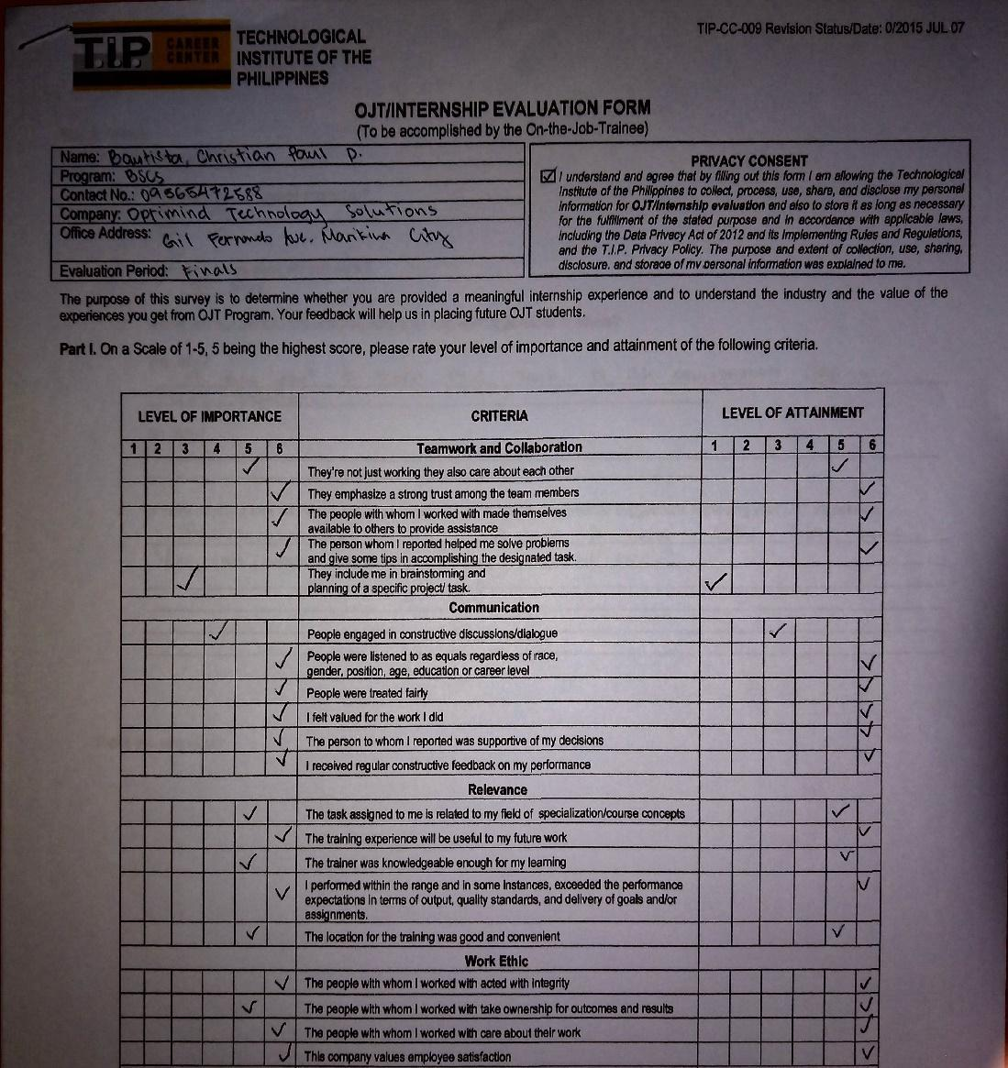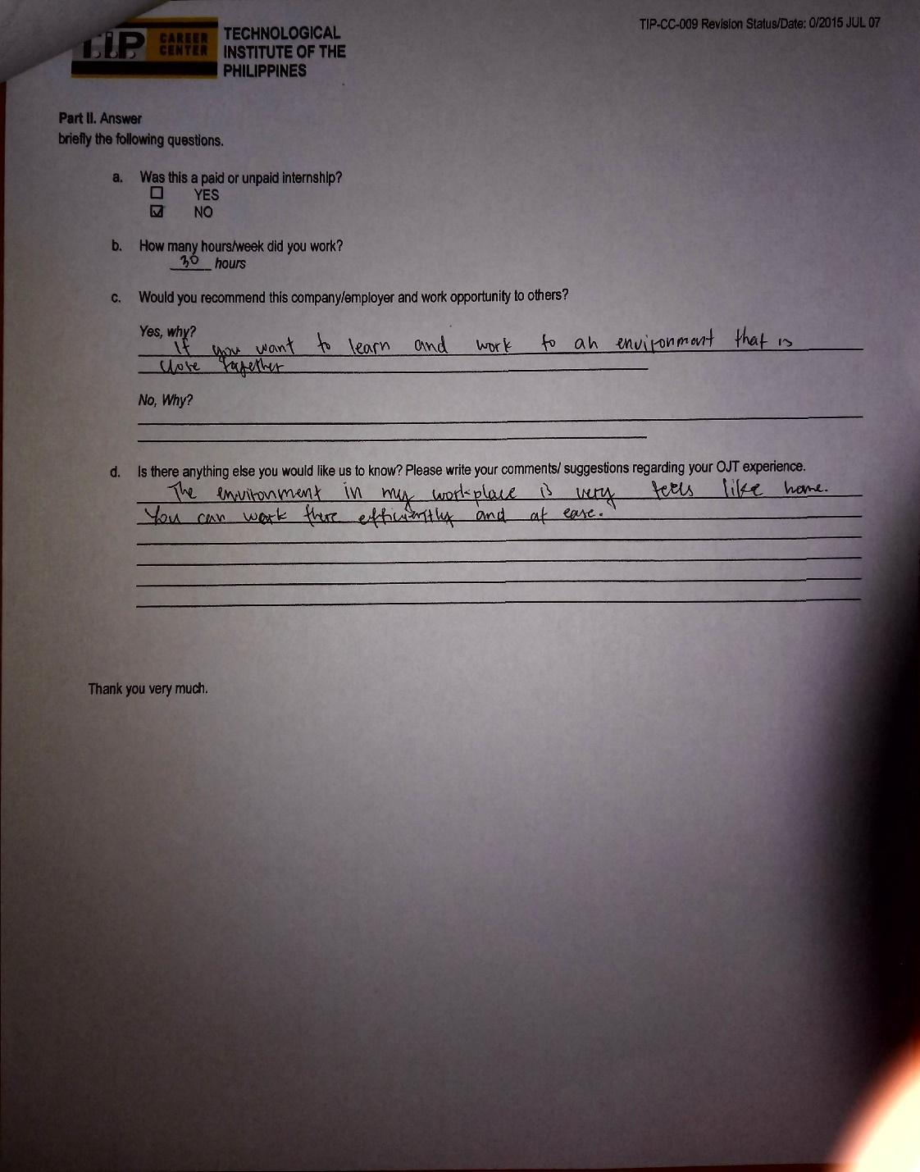

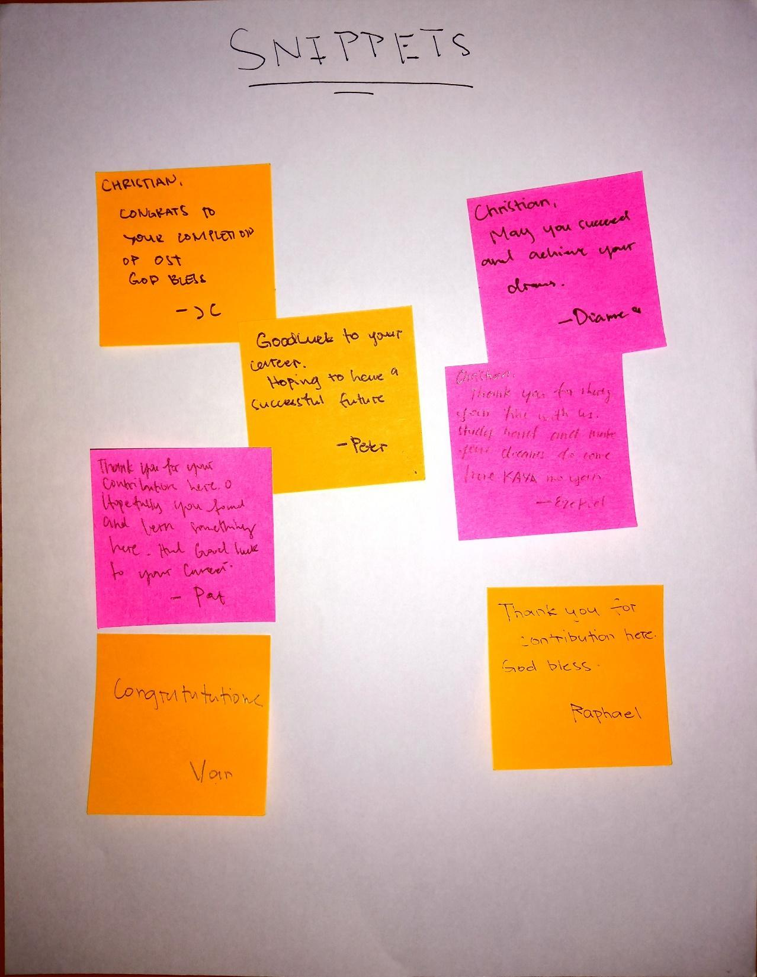

* + 1. **OB SHAD** SHADOWING REPORT PICTURES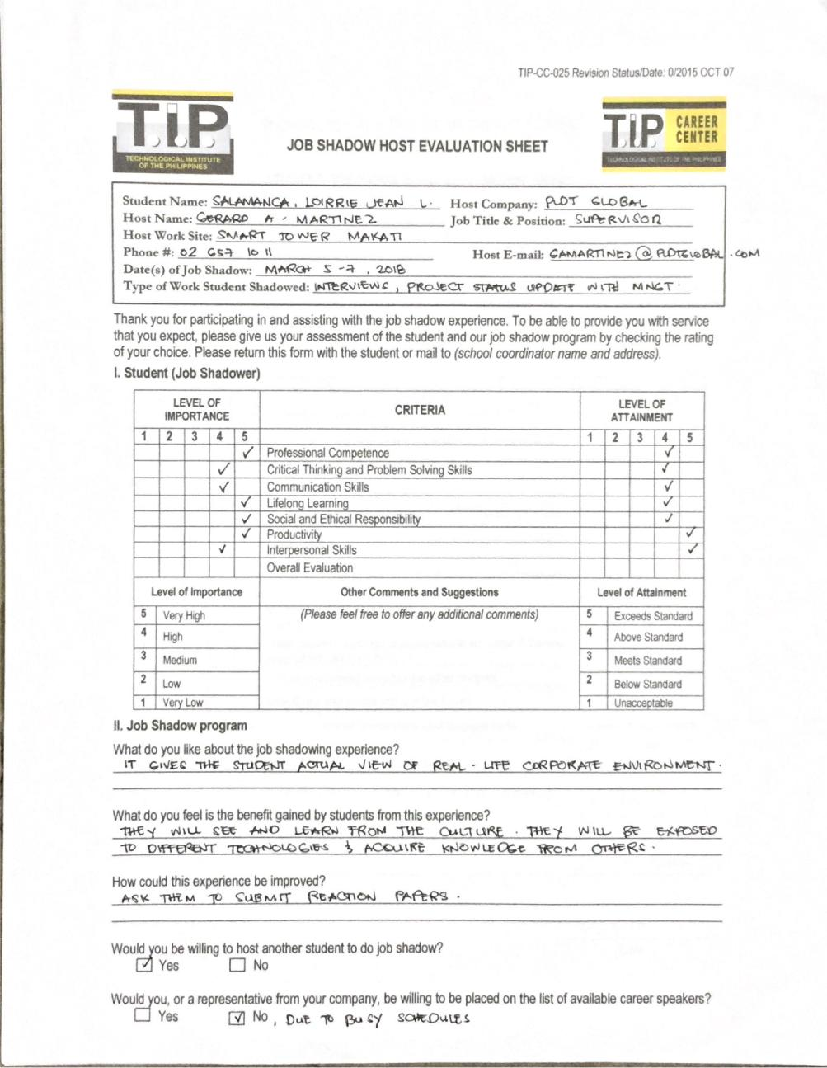

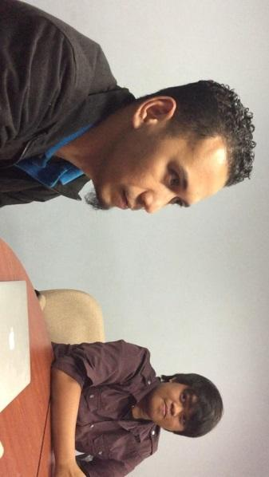

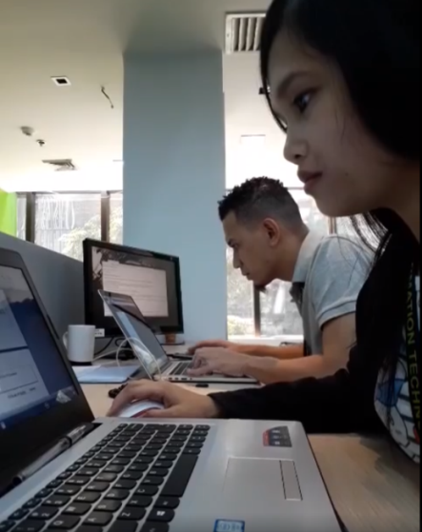

**March 6 & 9, 2018** – I performed my first job shadowing experience in hiring interview. I was able to witness how they asked questions to the applicant and expressed his thought according to his skills and knowledge.

The job shadow report learning of the following:

* Performed job shadowing hiring interview for iOS developer and Android developer
* Identified the structured interview
* Determined the candidate skill level
* Established the different principles of effective interview
* Witnessed base questions on the specific knowledge, skills, and abilities
* Observed them how to decide whether the applicant fits the job
* Learned techniques in answering the interview questions
* Joined hiring interview with the IT Supervisor and Project Manager
* Asked questions also to applicants about his achievements
* Examined the application he did
* Described the work environment in which he will most effectively to be contributing
* Took one (1) hour job interview
  + 1. **APPENDICES**

## Endorsement Letter

## On-the-Job Training/Practicum Agreement and Liability Waiver

## Parent’s Waiver

## Trainee’s Curriculum Vitae

## Certificate of Completion

## OJT Request Form

## Certification of Acceptance for OJT

## OJT Prelim Performance Evaluation

## OJT Midterm Performance Evaluation

## Success Stories

## OJT Evaluation Form

## OJT/Practicum Assessment Tool (*Rubrics *ITE Tool, Weekly Report Rubric, Final Written Report rubric)*

## Snippets

## Reflective Journal *My OJT hunting experience and my experience In OJT

## CD *contains softcopy of final written report

## Endorsement Letter

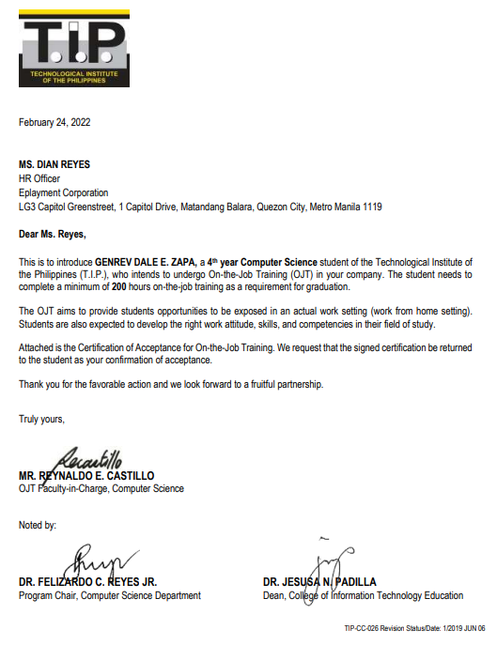

## On-the-Job Training/Practicum Agreement and Liability Waiver

## Parent’s Waiver

## Trainee’s Curriculum Vitae

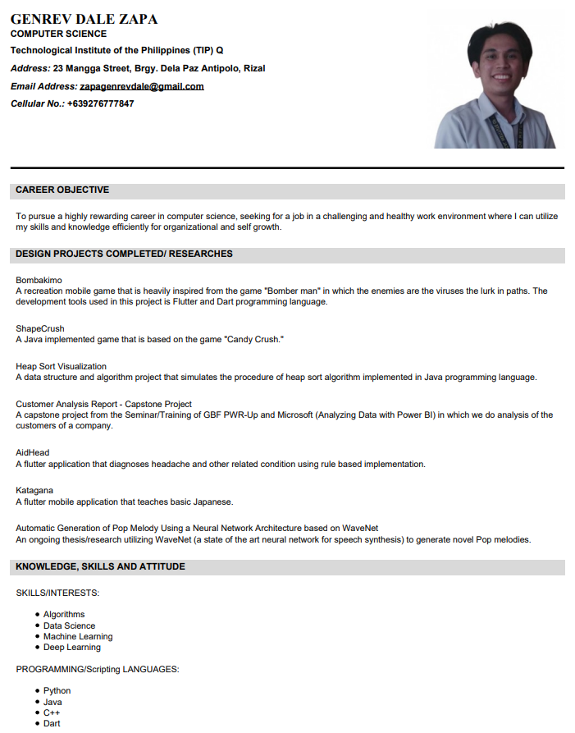

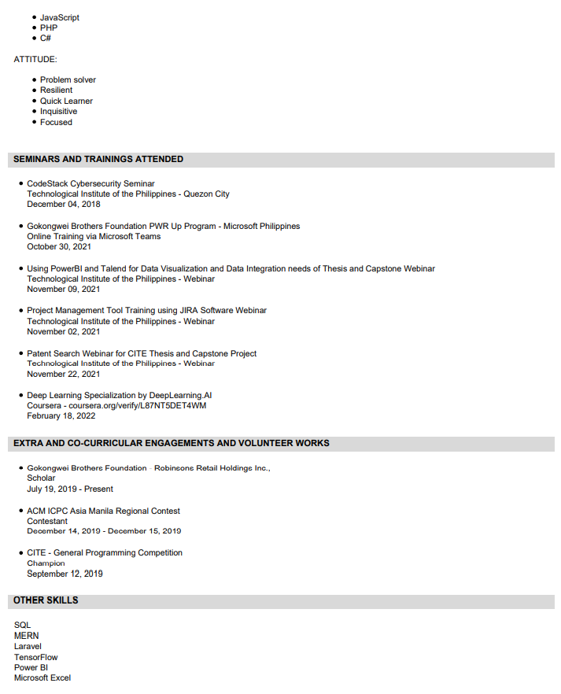

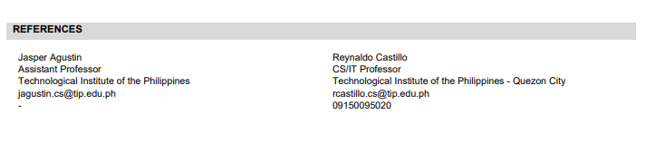

## Certificate of Completion

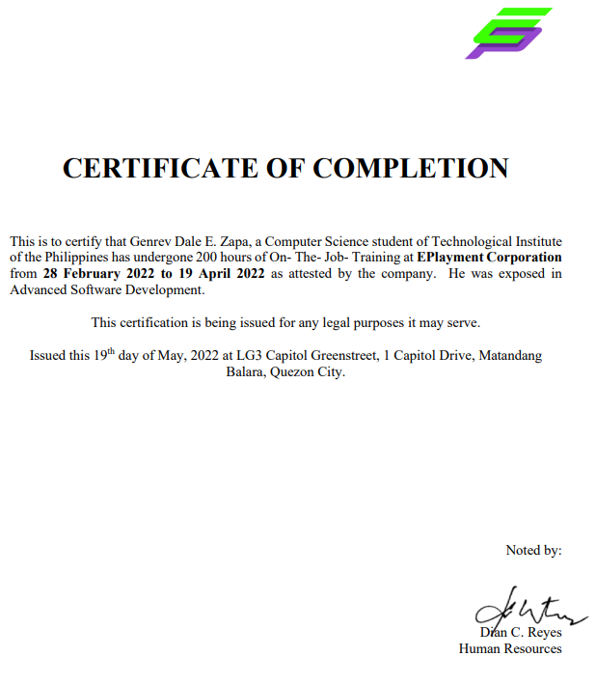

## OJT Request Form

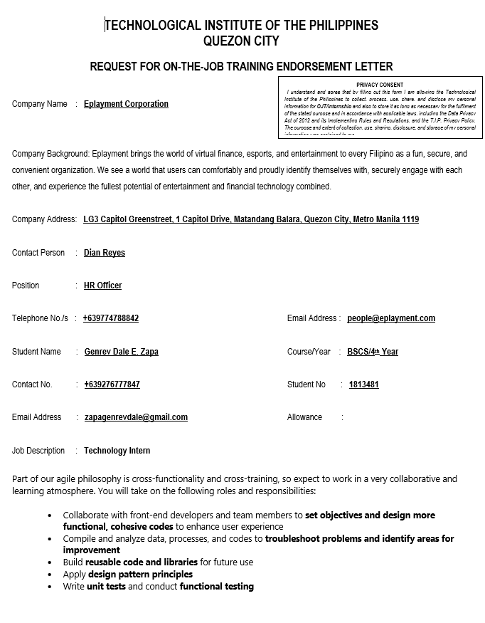

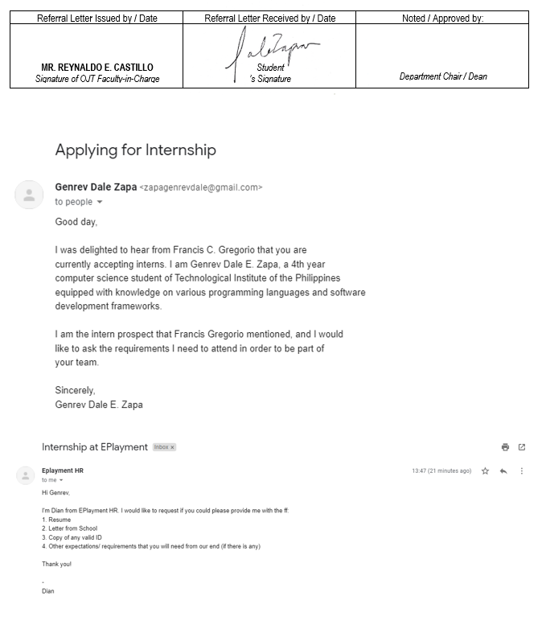

## Certification of Acceptance for OJT

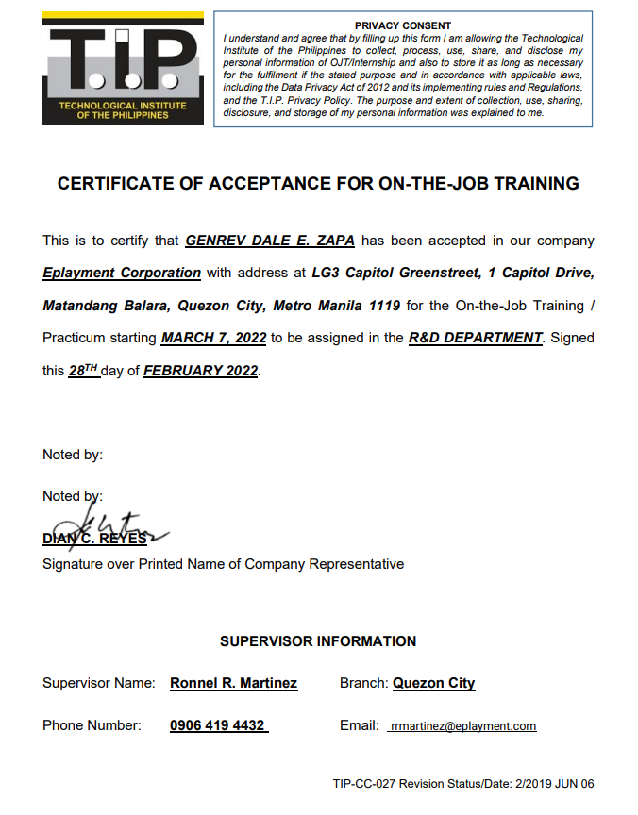

## OJT Prelim Performance Evaluation

## OJT Midterm Performance Evaluation

## Success Stories

## OJT Evaluation Form

## OJT/Practicum Assessment Tool (*Rubrics *ITE Tool, Weekly Report Rubric, Final Written Report rubric)*

## Snippets

## Reflective Journal *My OJT hunting experience and my experience In OJT

CD *contains softcopy of final written report

**OJT Requirements Completion Form*( KINDLY USE THE NEW FORM)***

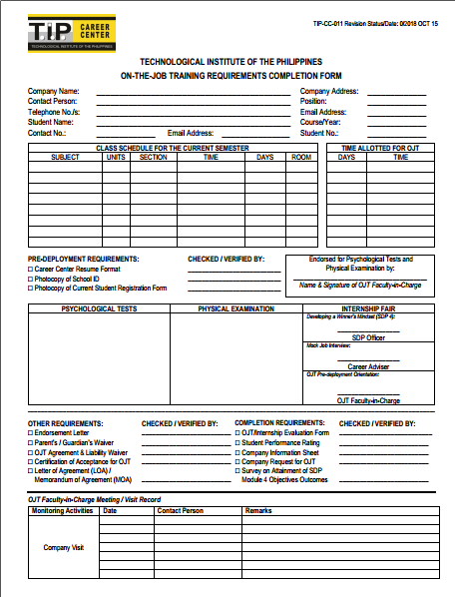

**Endorsement Letter *( KINDLY USE THE NEW FORM)***

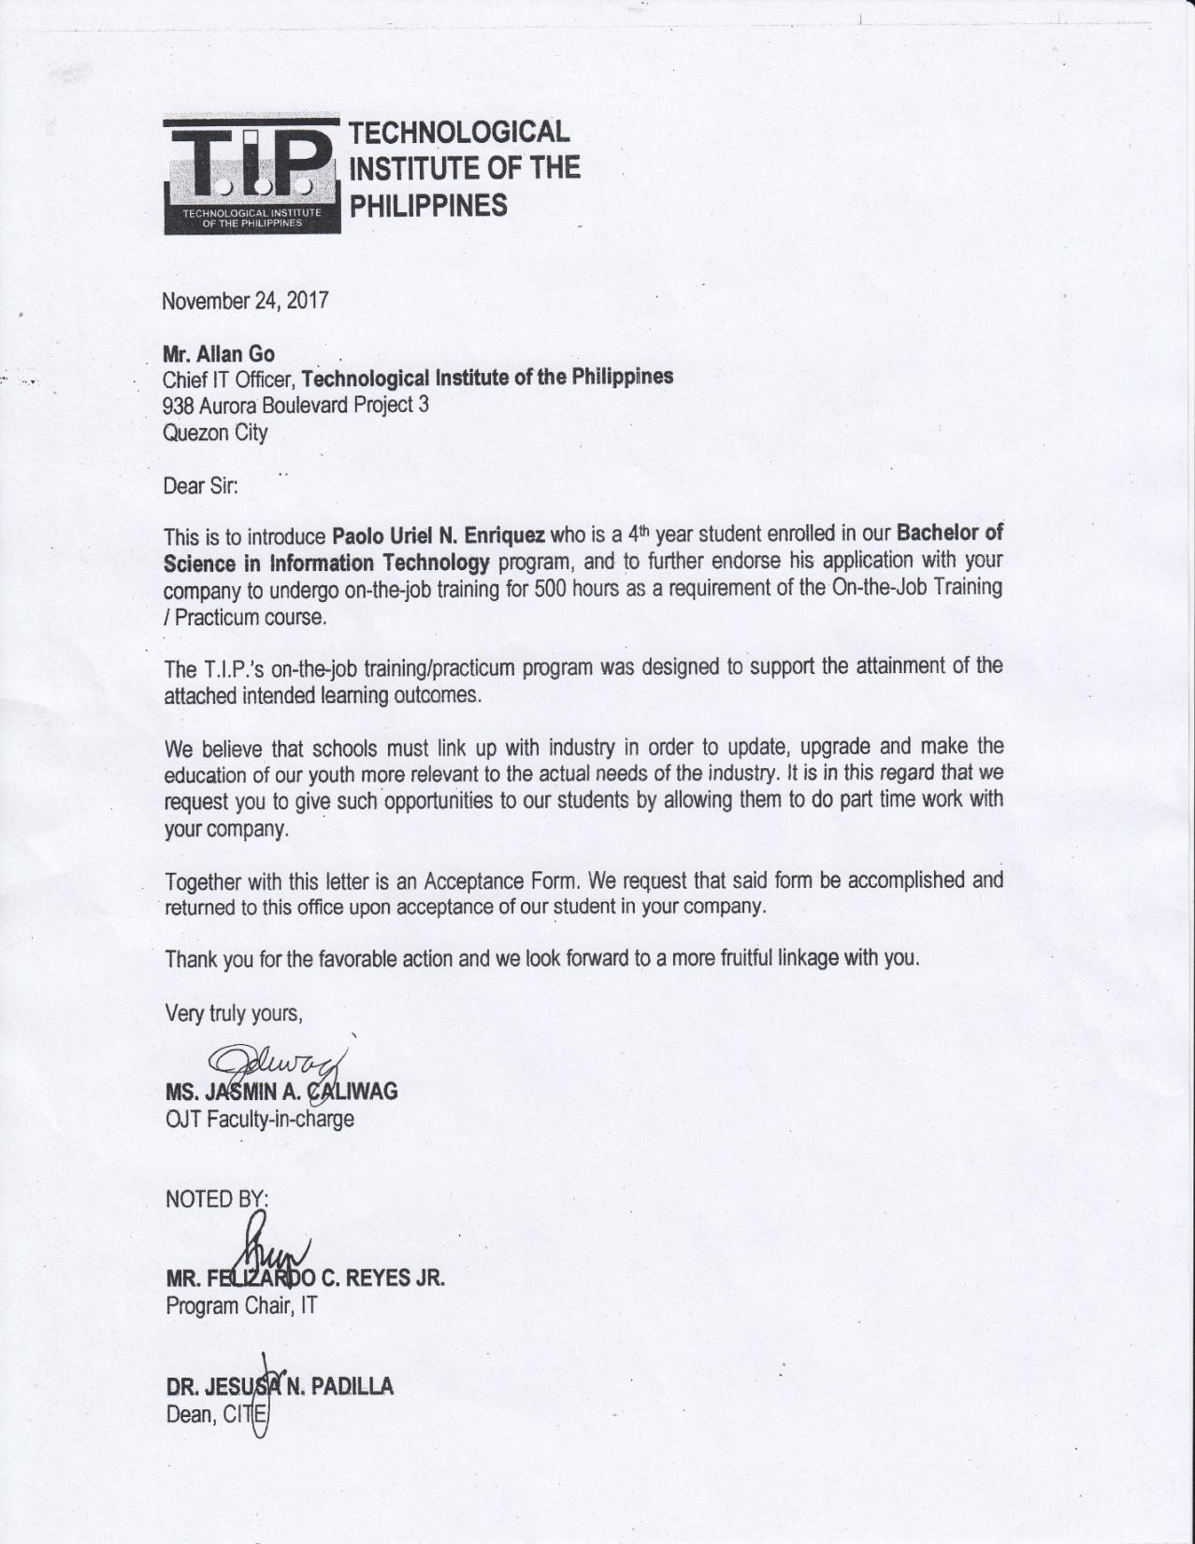

**OJT/Practicum Agreement and Liability Waiver for the Company *( KINDLY USE THE NEW FORM)***

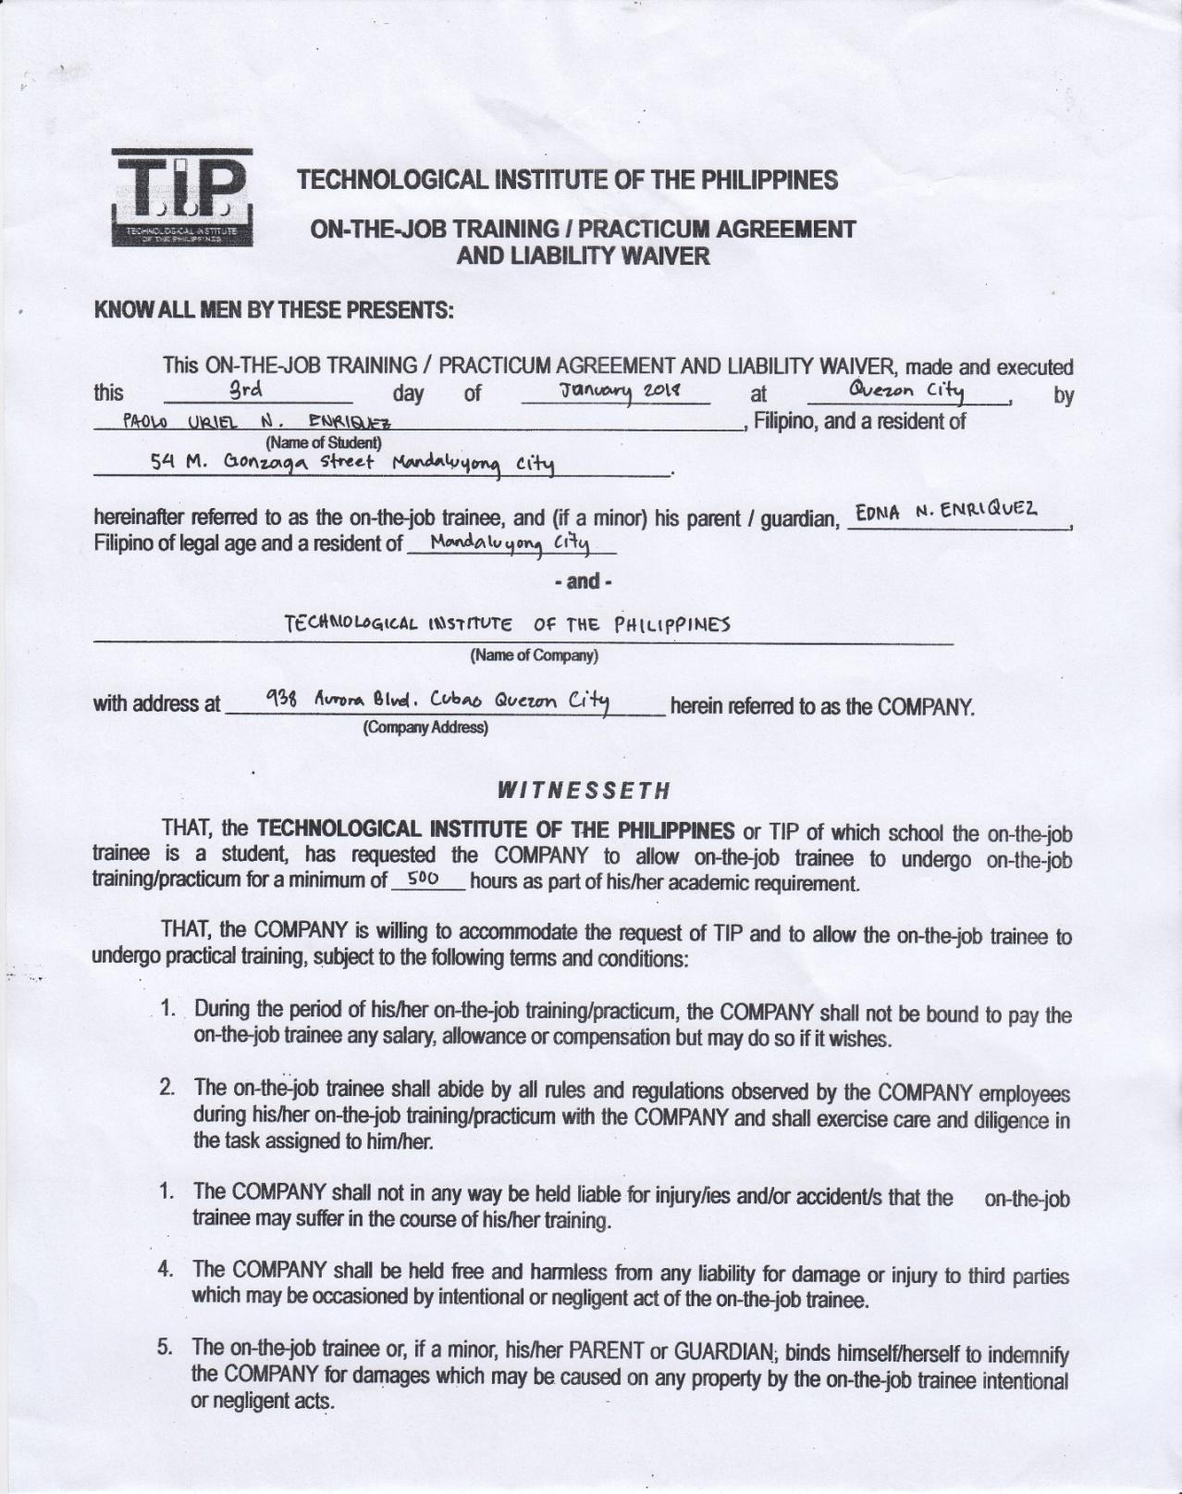

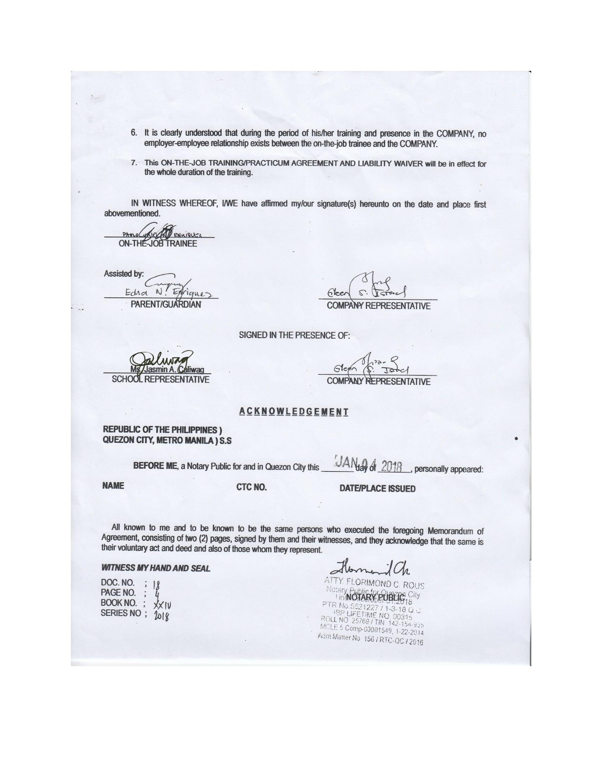

**Student’s Parent’s Waiver *( KINDLY USE THE NEW FORM)***

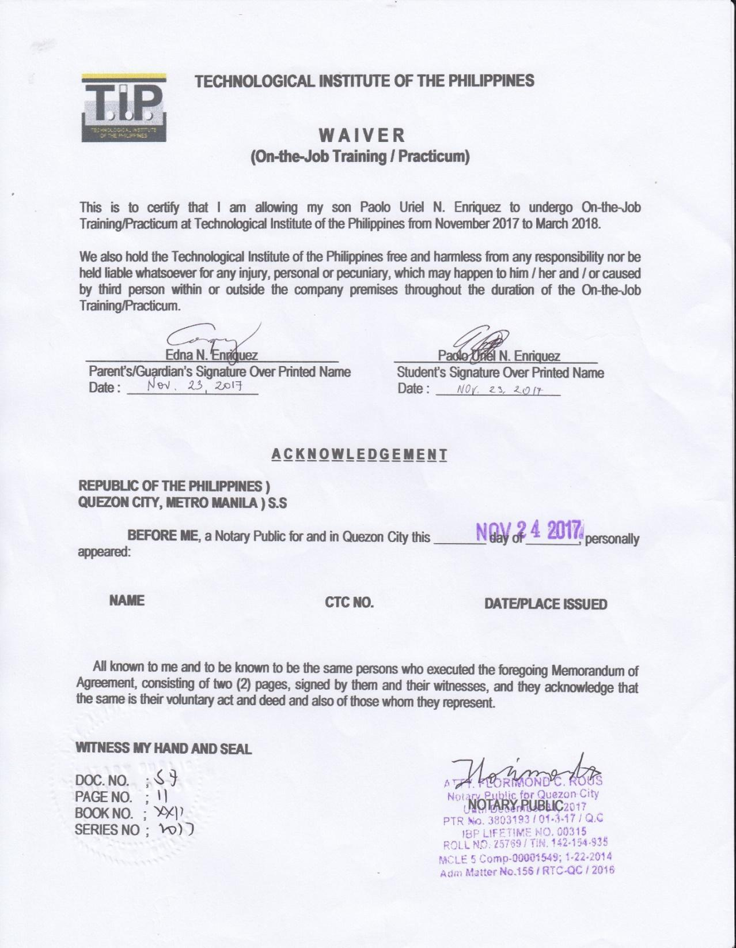

**Certification of Acceptance for OJT *( KINDLY USE THE NEW FORM)***

**Winning Mindset Certificate *( KINDLY USE THE NEW FORM)***

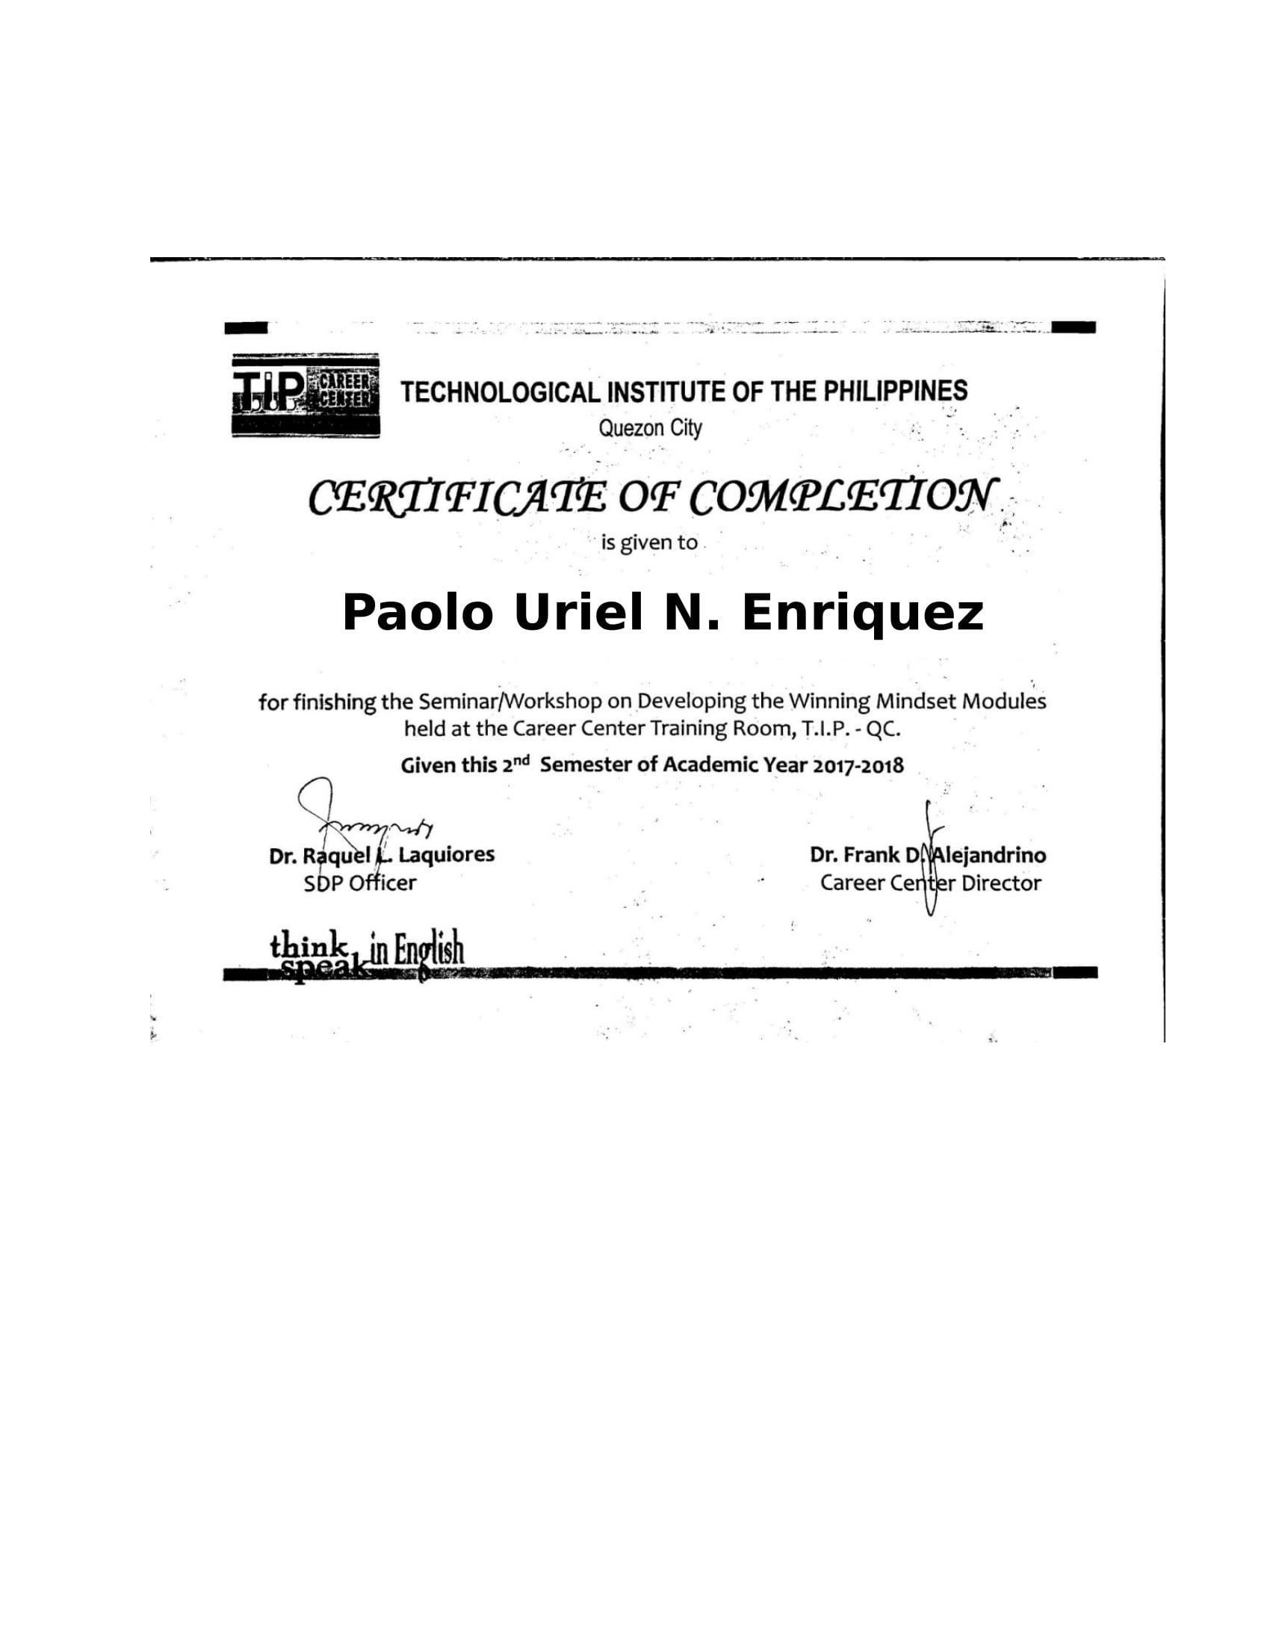

**Certificate of Completion**

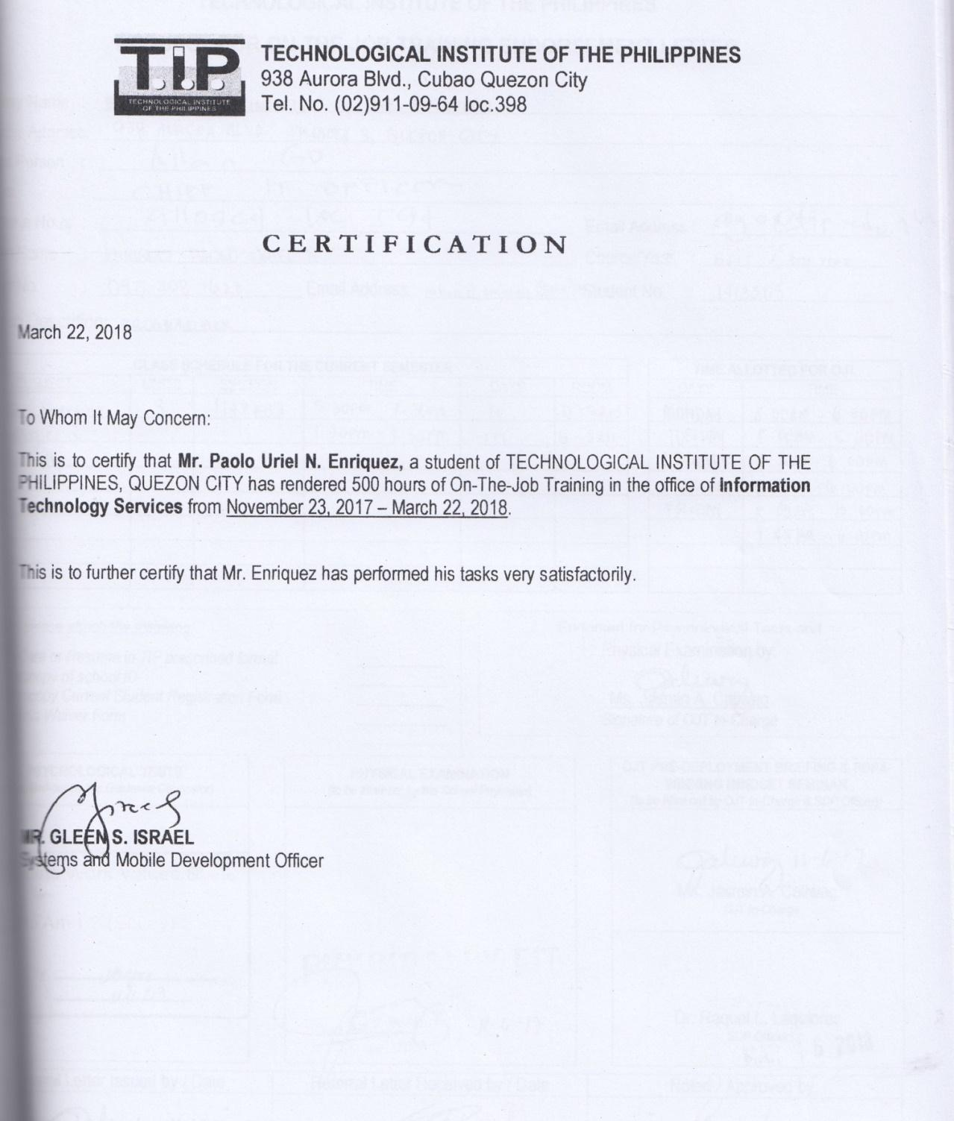

**Trainee’s Curriculum Vitae *( KINDLY USE THE NEW FORM)***

## Letter

## On-the-Job Training/Practicum Agreement and Liability Waiver

## Parent’s Waiver

## Trainee’s Curriculum Vitae

## Certificate of Completion

## OJT Request Form

## Certification of Acceptance for OJT

## OJT Prelim Performance Evaluation

## OJT Midterm Performance Evaluation

## Success Stories

## OJT Evaluation Form

## OJT/Practicum Assessment Tool (*Rubrics *ITE Tool, Weekly Report Rubric, Final Written Report rubric)*

## Snippets

## Reflective Journal *My OJT hunting experience and my experience In OJT

## CD *contains softcopy of final written report

**OJT/Internship Evaluation *( KINDLY USE THE NEW FORM)***

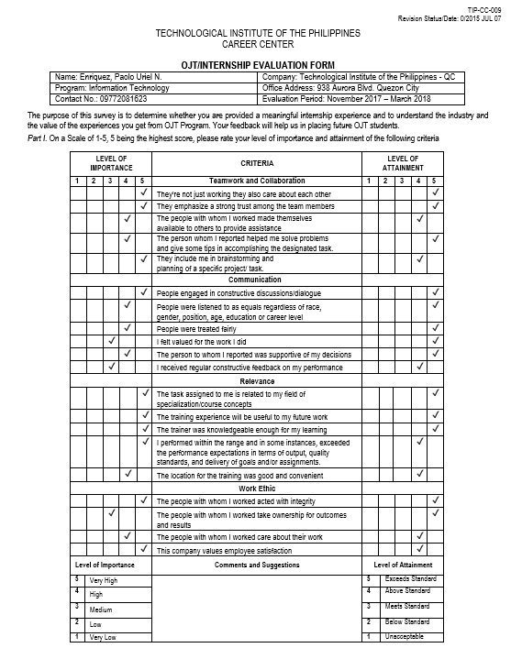

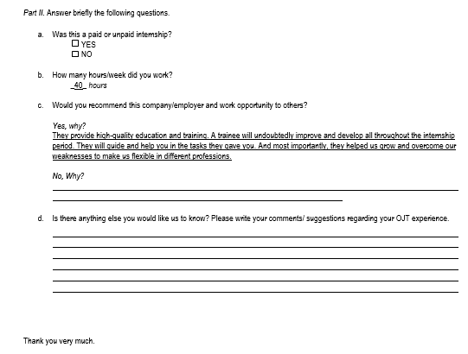

**Student Performance Rating *( KINDLY USE THE NEW FORM)***

